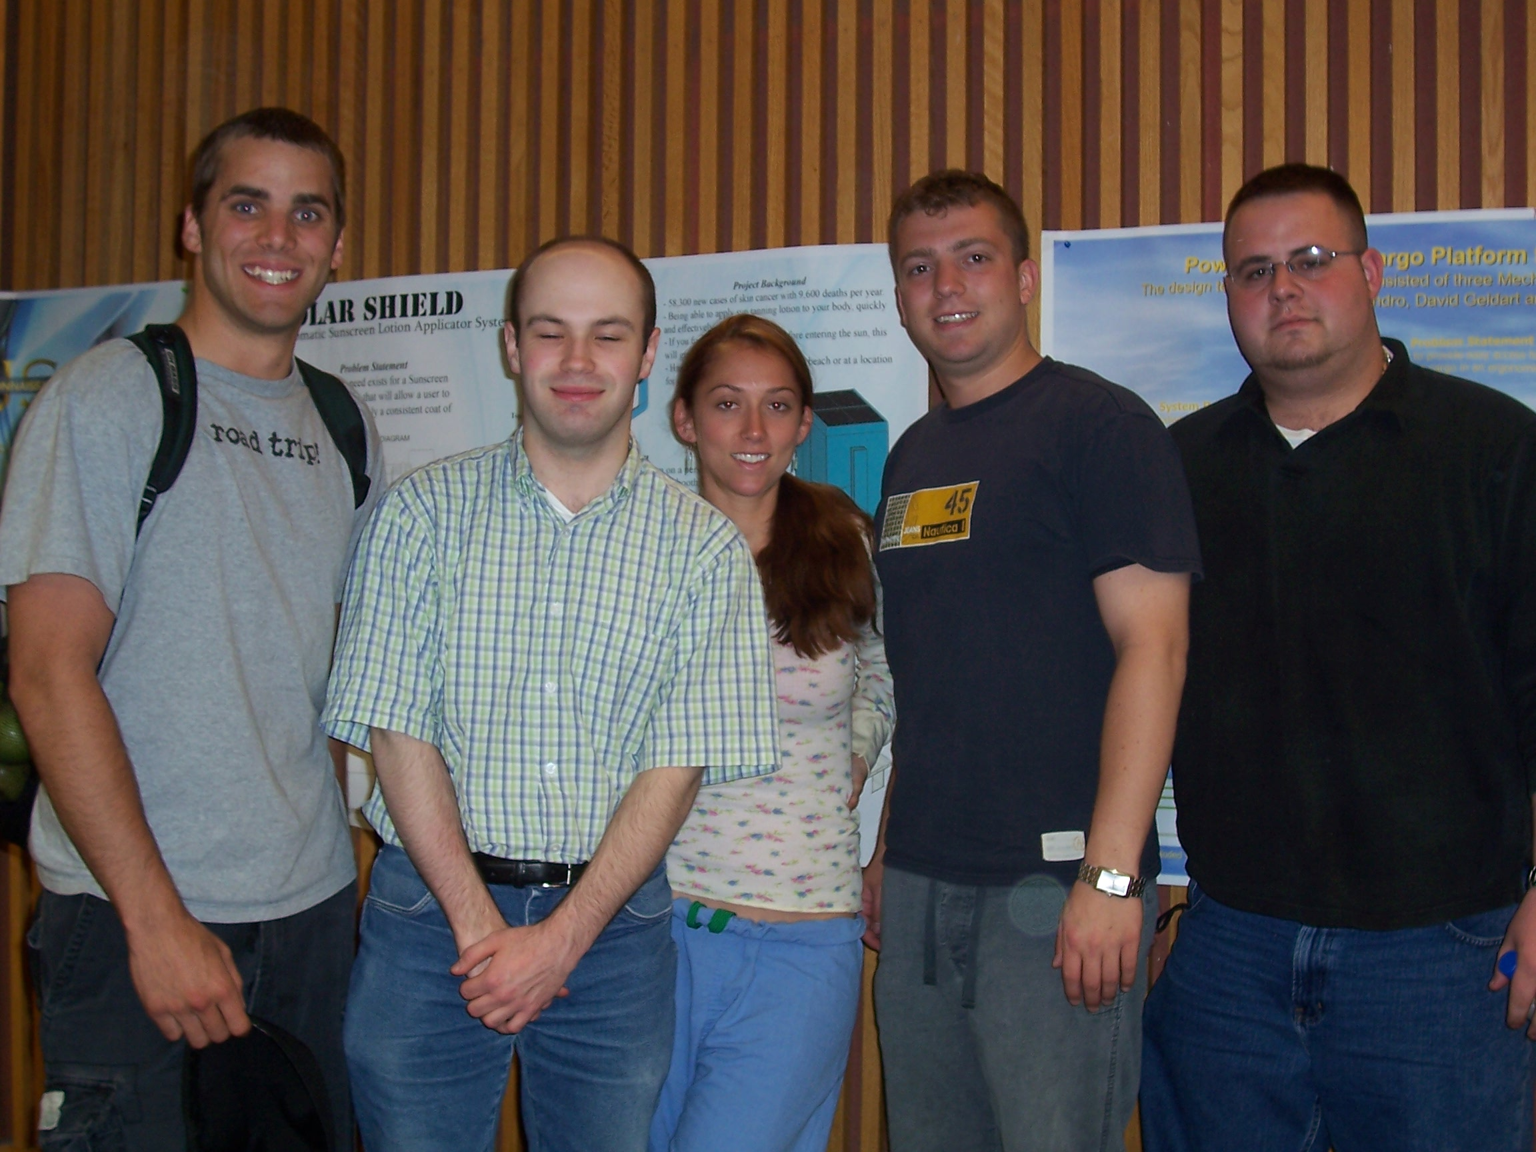

Project 1
DNA Separator Device
Prof. Ruberti

Forrest Harrington, Jason McDermott, Ashley Mattison, Alex Lessis, Michael Zabbo

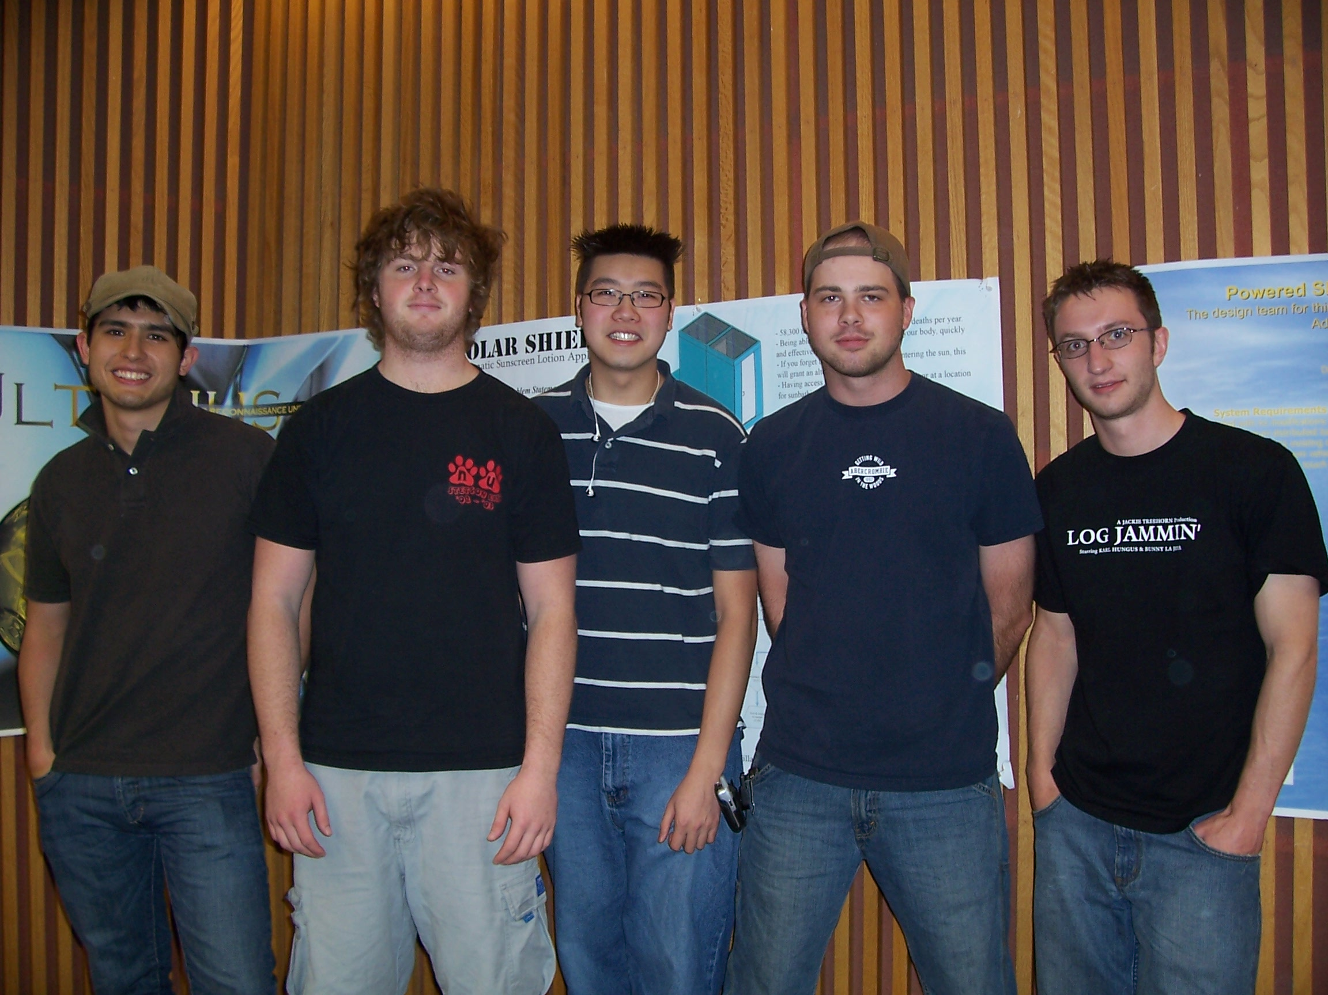

Project 2
Syringe pump/heater/cooler
Prof. Taslim

Mark Breneman, Dan Leathem, Ben Ngo, Nick Lecan, Matt Lacharelle

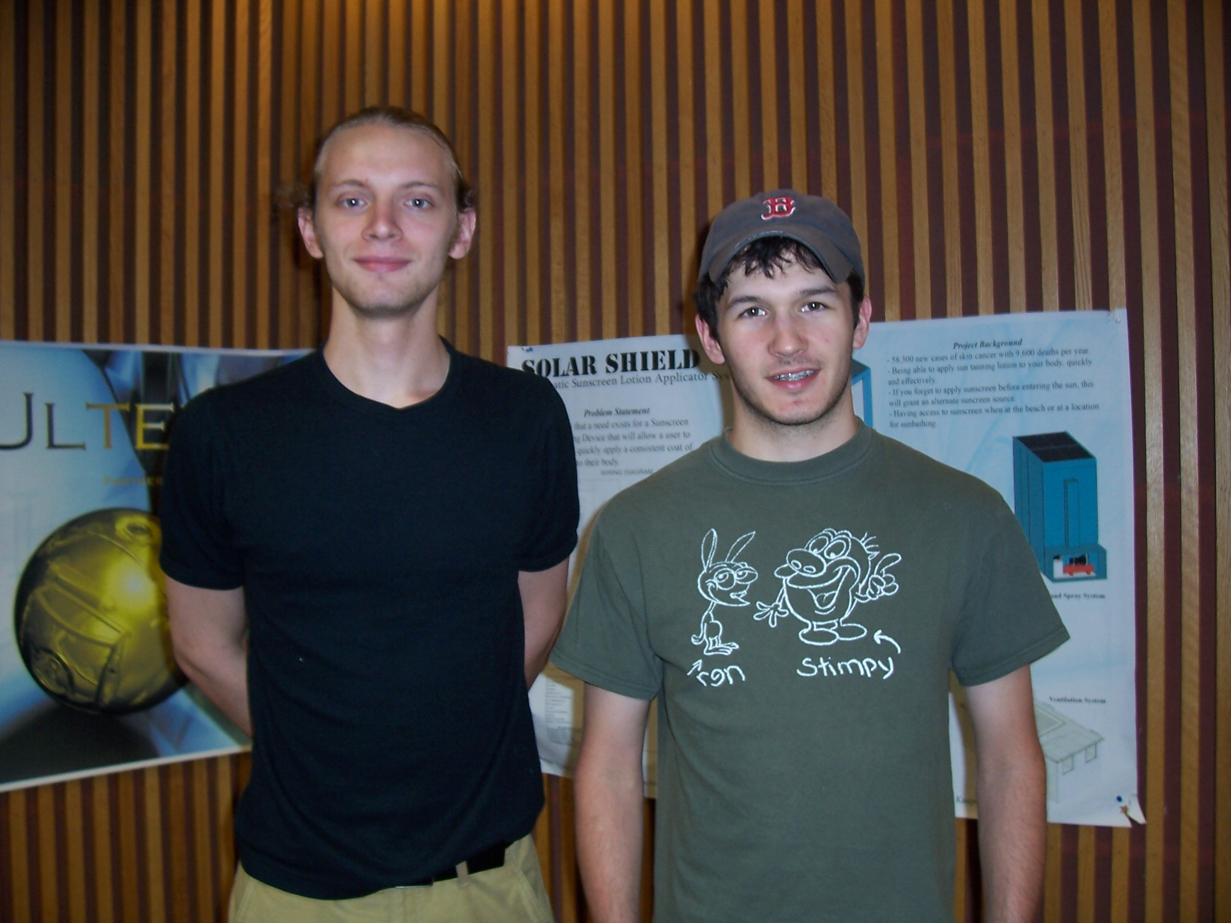

Project 3
Xandex Ink Cartridge: Phase II
Prof. Taslim

Aaron Grossman, Joe Malone, Jim McIntosh (not pictured)

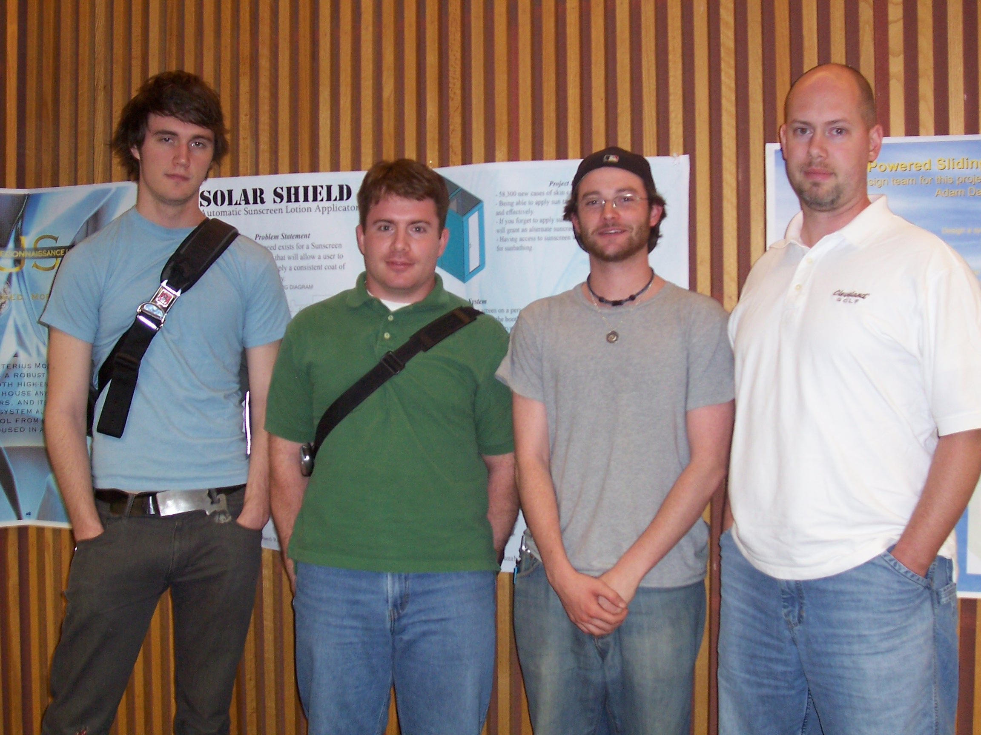

Project 4
Sterilization System for Microfluidics
Prof. Taslim

Mike Mckay, Nick Roulleau, Mike Vose, Michael Racette

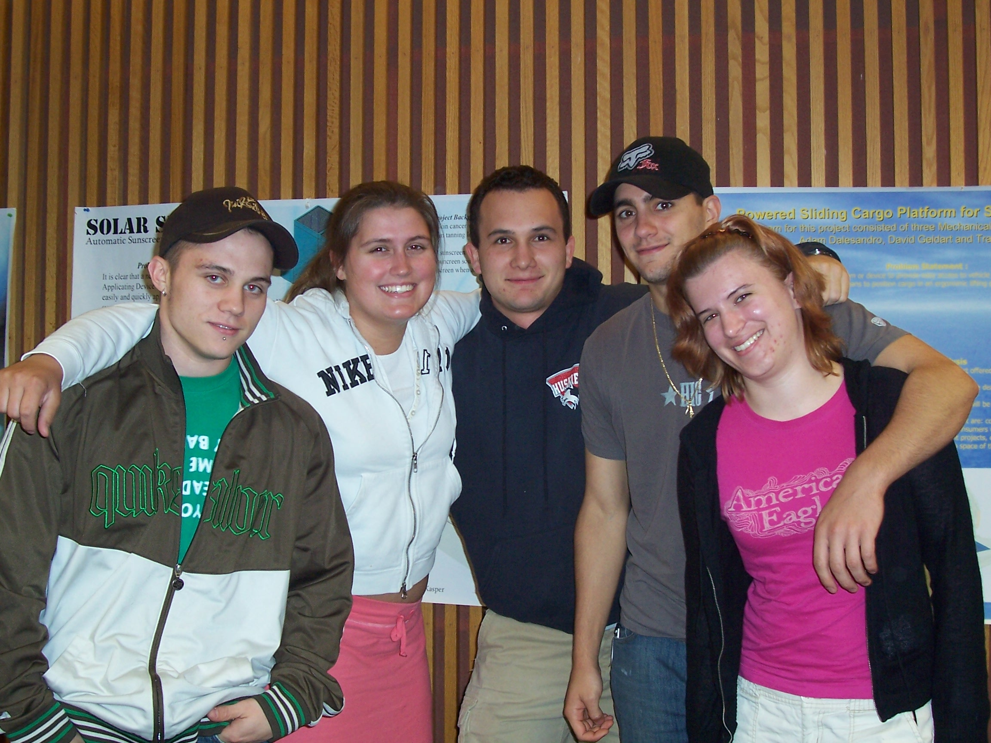

Project 5
Human Jaw Motion Simulator
Prof. Muftu

James Maloof, Mia Monte-Lowrey, Bryan Galer, Nate Hockenberry, Katelyn O'Donnell

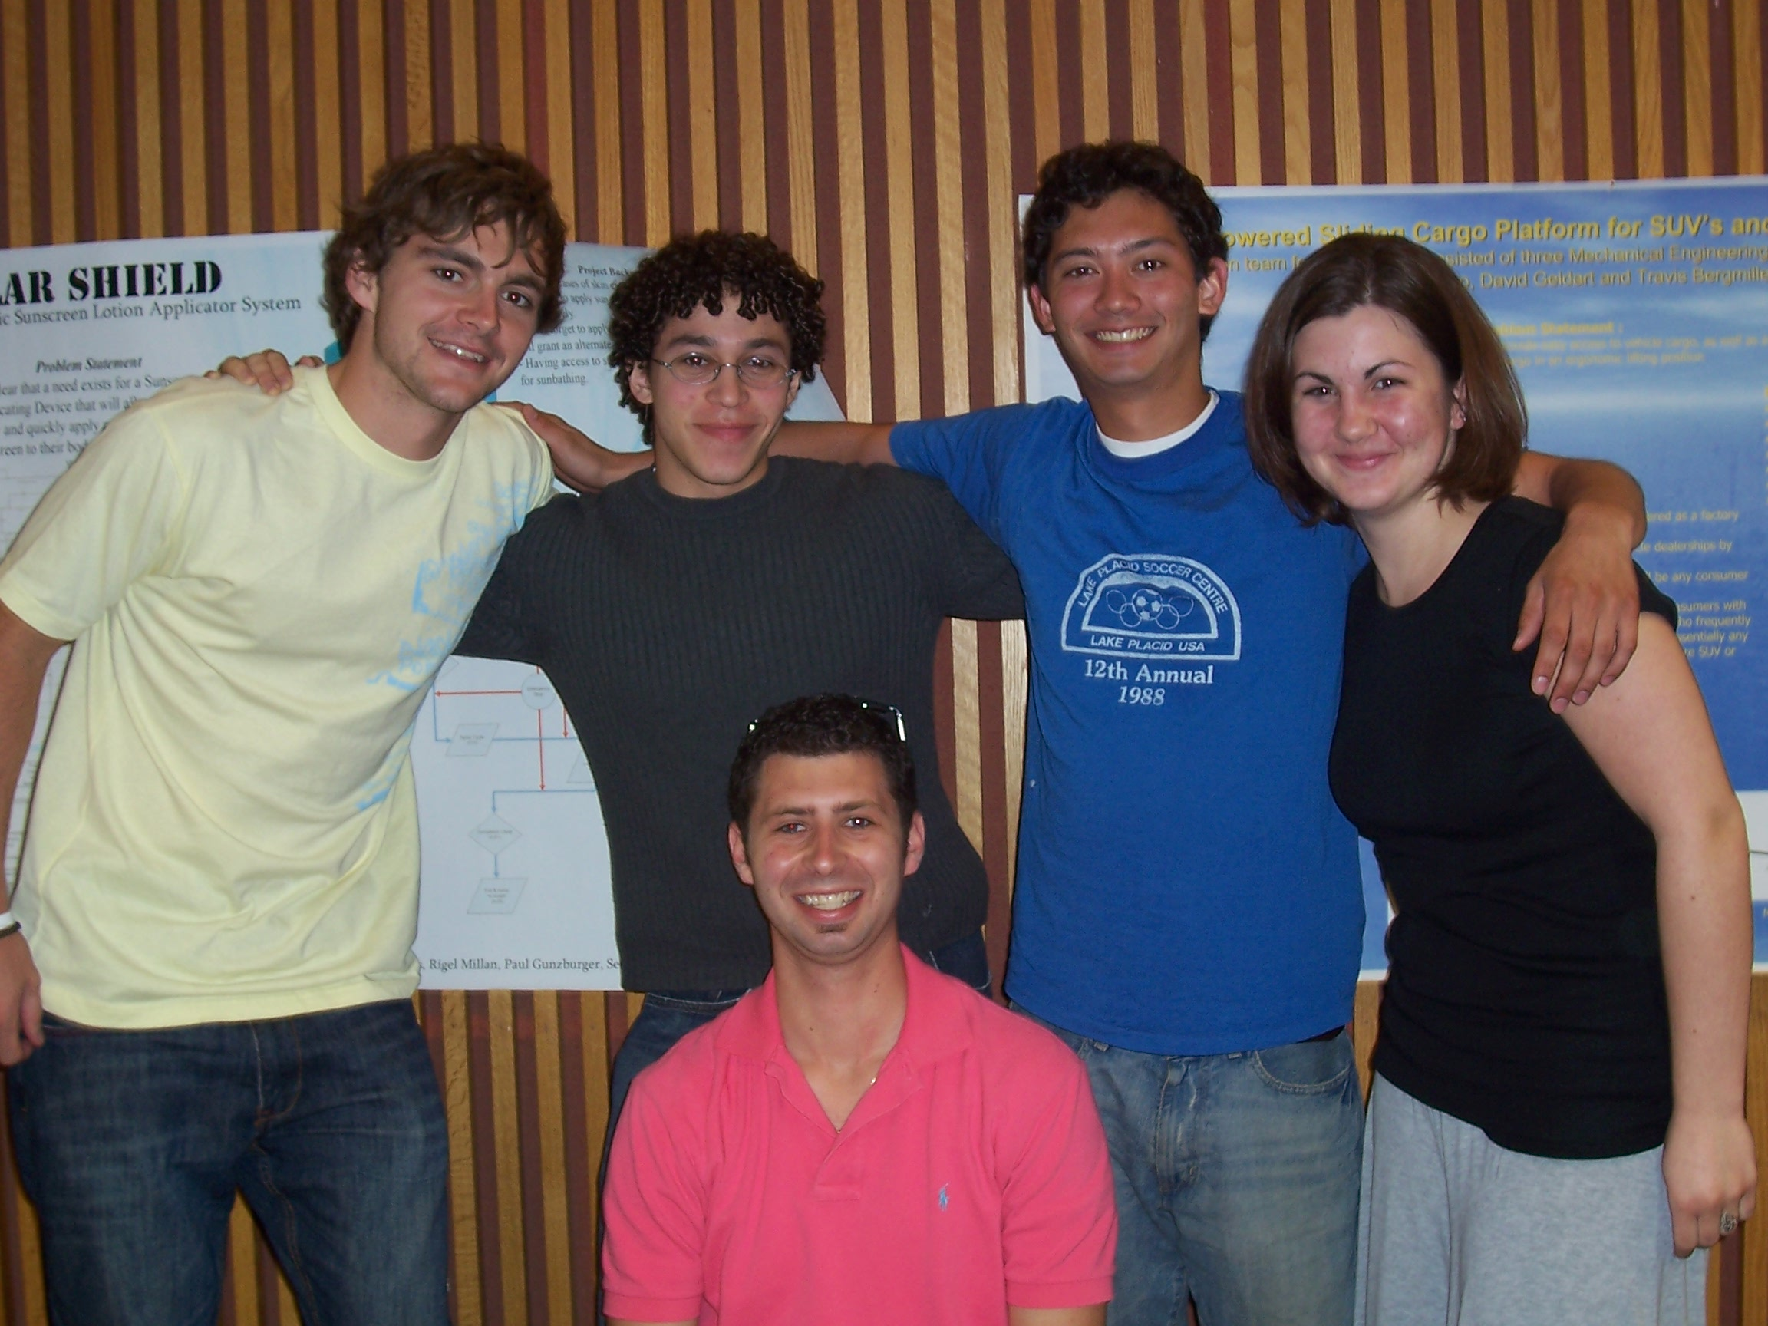

Project 6
Secondary Payload Adapter
Prof. Muftu

Ben Kneppers, Nate Matcheson, Matt Krenek (front center), Rylan Summit, Rachelle Parsons

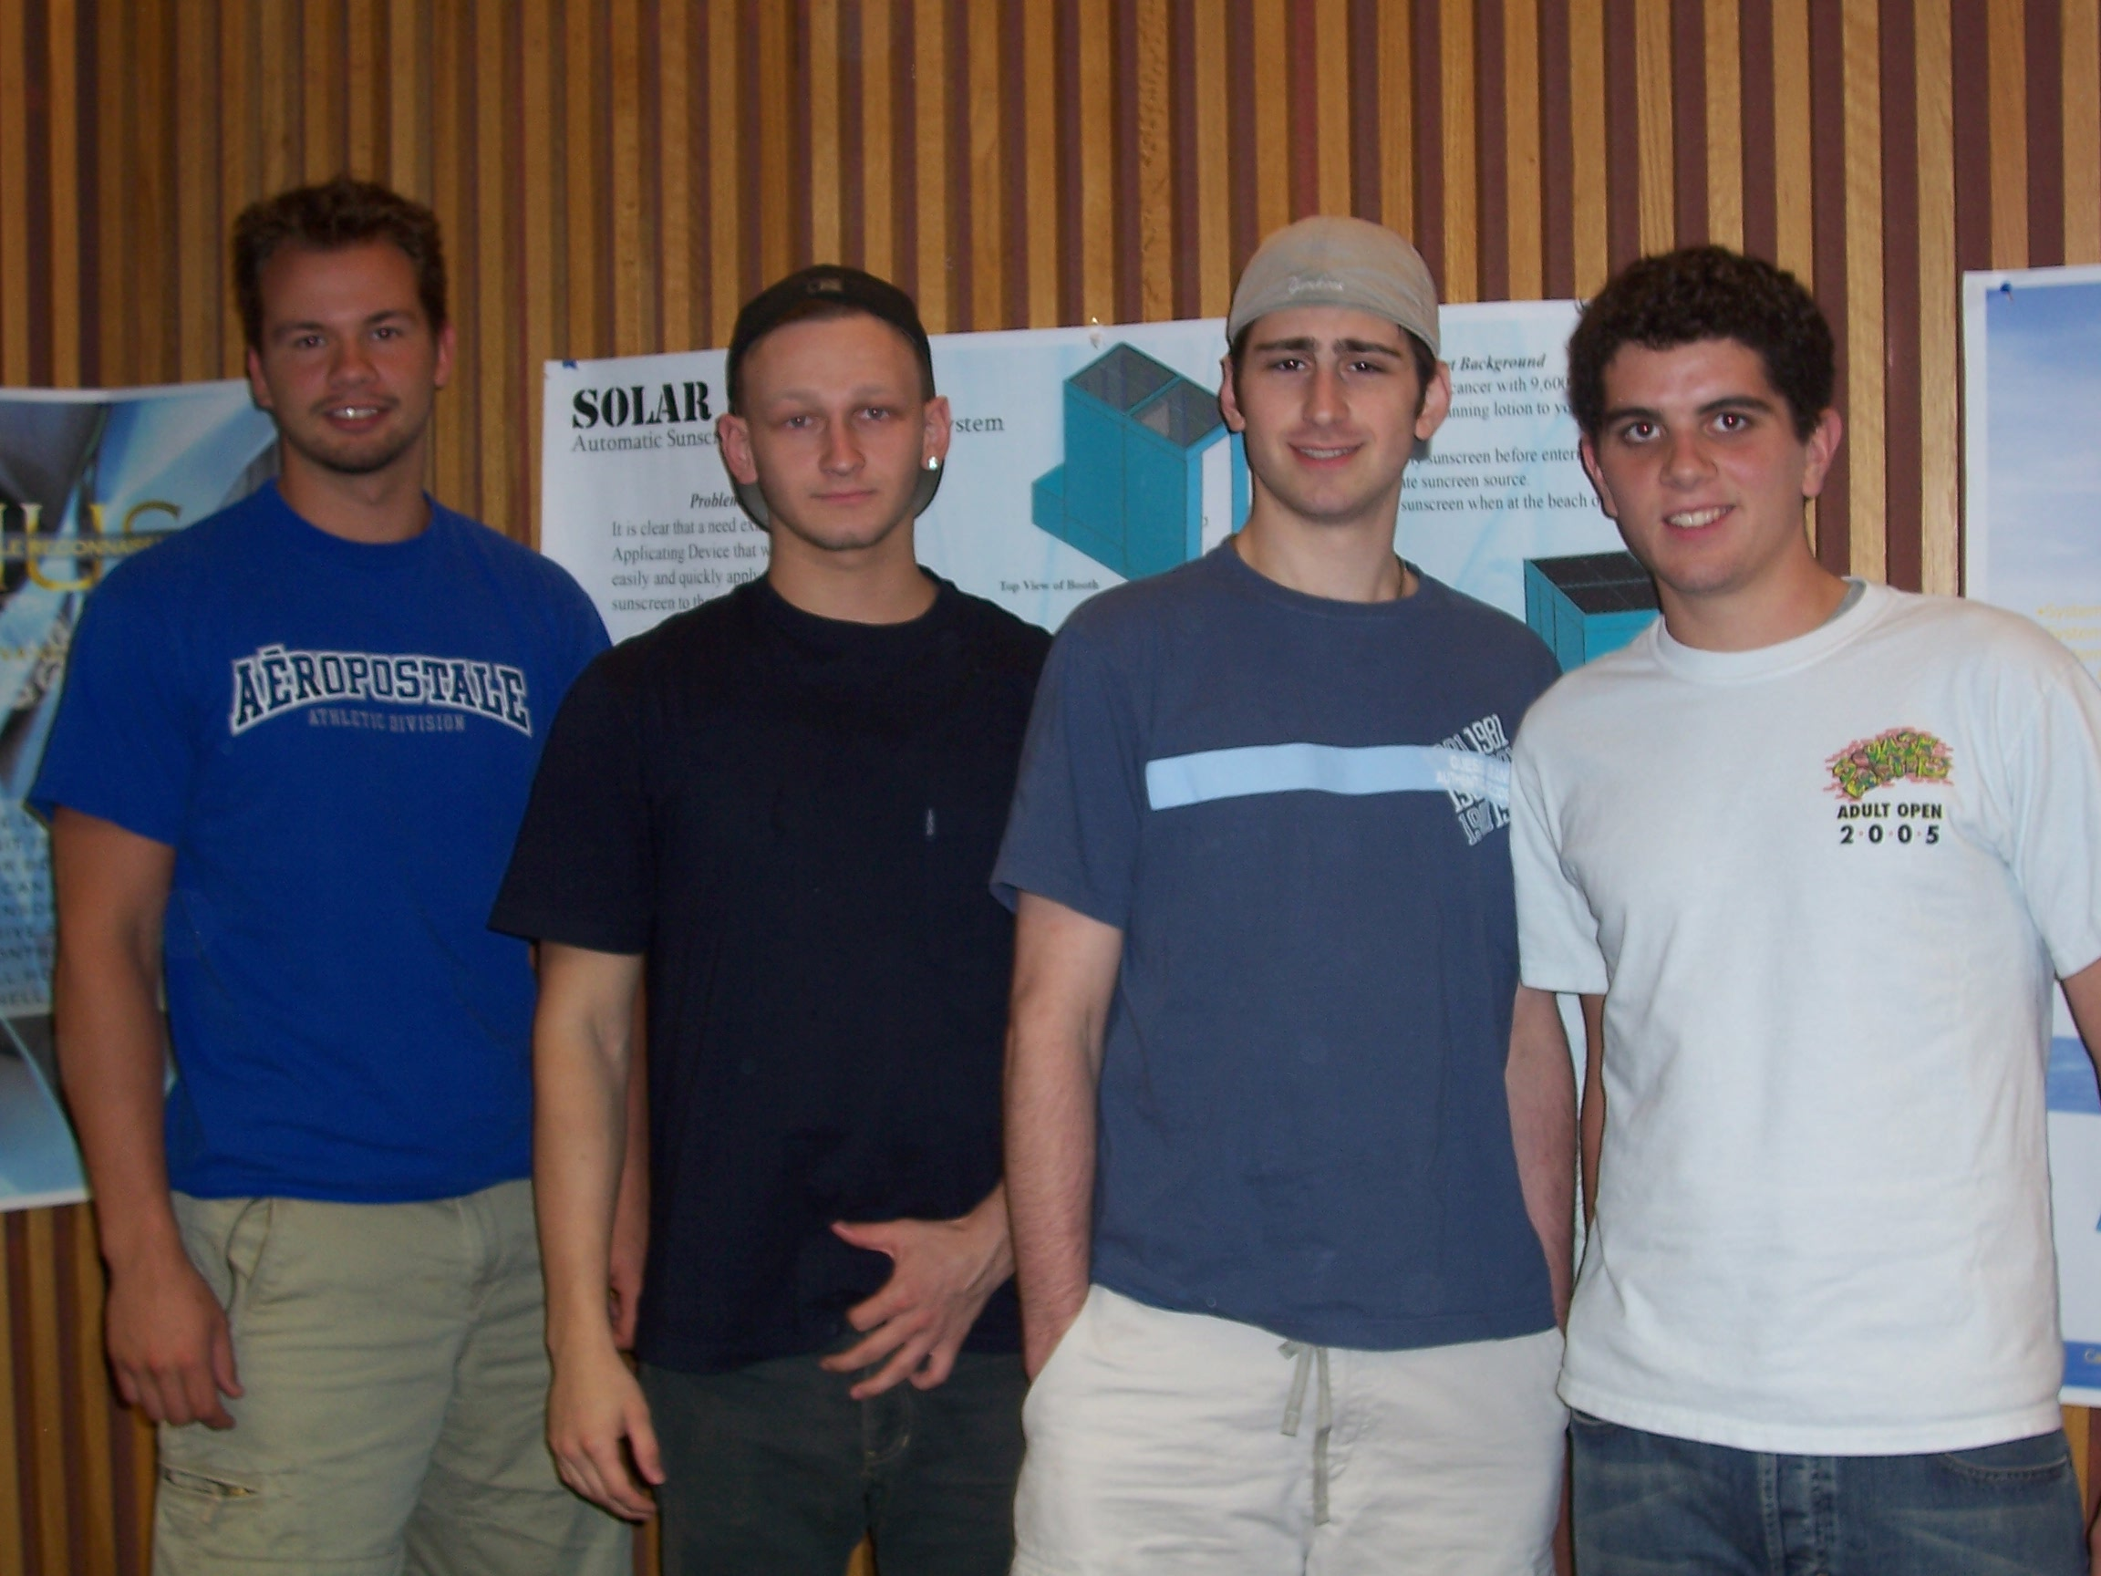

Project 7
SimonSAT: Small Satellite Project
Prof. Kowalski

Steve Souza, Jason Stricker, Gene Rossov, Jack Rafalowski

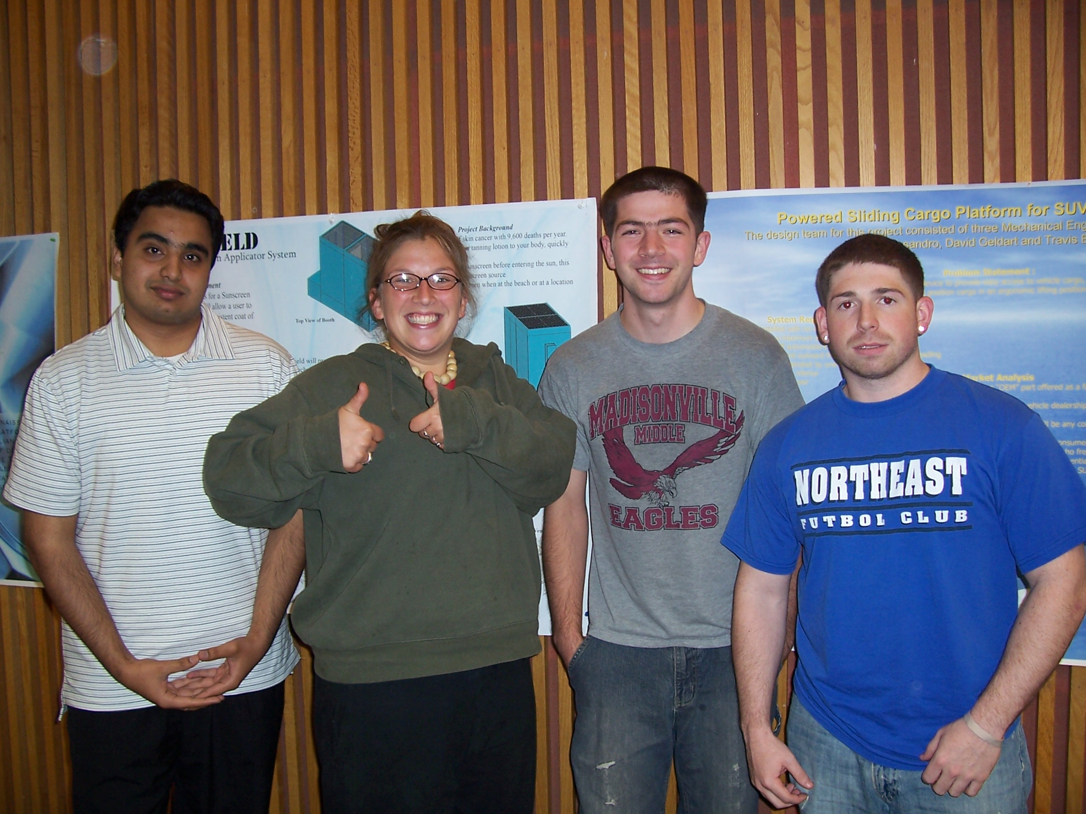

Project 8
Thermally Controlled Electron Microscope Stage
Prof. Kowalski

Mohammed Ali, Sarah Kaufmann, Dave Rezac, John Delcore

