Infrared Windshield Defroster

Design Team
Todd Brown, Christopher Grace
Scott Lynch, Scotlund McIntosh, Katie Melanson

Design Advisor

Prof. Greg Kowalski

Abstract
The objective of this project is to design and build a device that is able to remotely defrost a car windshield more effectively than current methods while producing a low environmental impact. Current methods include removing the ice using plastic scrapers or melting the ice by running a car on idle to heat up the windshield, prove to be ineffective or environmentally damaging. This device must be able to melt up to 1/8” of ice from a distance of 20’, while meeting the environmental design parameters detailed in the report. An infrared heating element will be used with a reflective shield to create a focused beam of energy that will be used to defrost the windshield. Heat transfer calculations determined the theoretical energy required to melt the ice to be 336 watts, and the amount of energy actually transferred through the focused beam will be determined experimentally. The testing of a scale model, which utilized diffuse visible light, showed a 380% increase when compared to the bulb without the reflector from the same distance. The results were used to select a heating element with the proper specifications to meet our design criteria. The heat transfer calculations were used as a tool to see how the system reacted in terms of time and power as other variables were changed. A set of heat transfer calculations were done on the proposed prototype model in order to perform material selection, and it was found that 6061-Aluminum would be acceptable. The prototype was tested to determine if the design performed as expected.

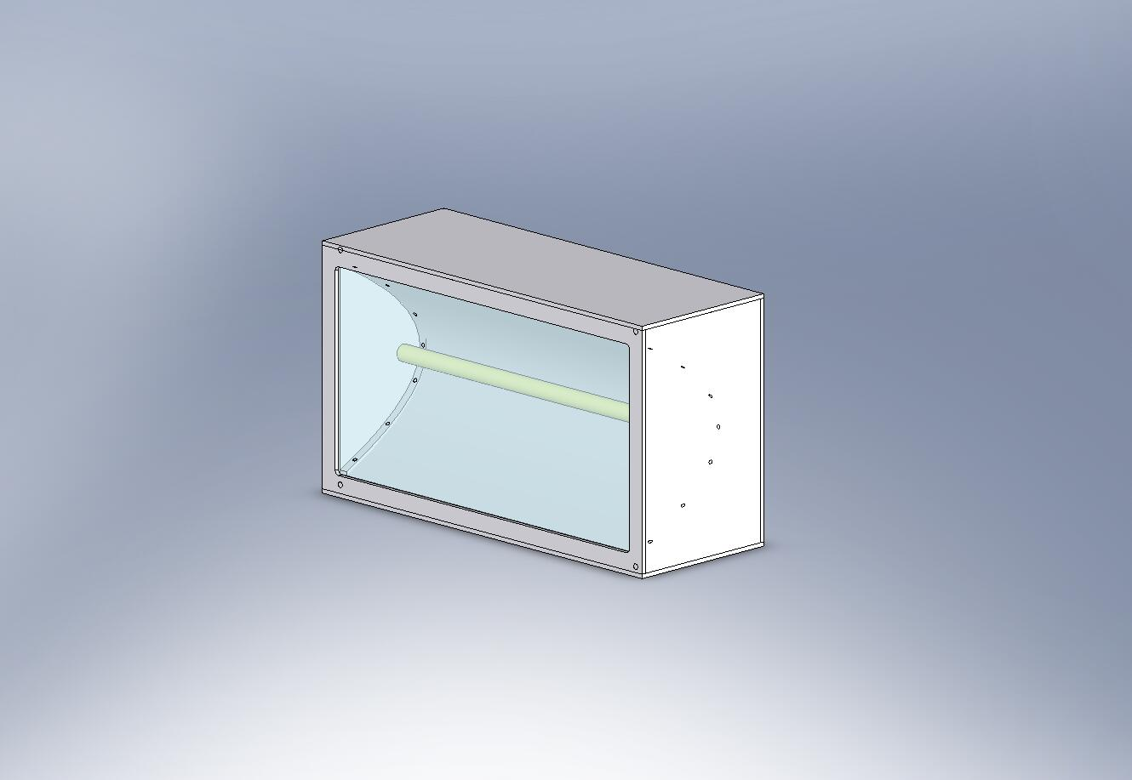
Medium Wave Quartz Element
Housing
Polished Aluminum Reflector
Prototype Construction
The Need for Project

The design of a device to improve current methods to remove frost from car windshields will benefit many people that live in temperate climates. | Automobiles in temperate climates are subjected to frost formation, which requires removal through inefficient manual methods or environmentally harmful actions. Plastic windshield scrapers are ineffective for removing thick layers of frost. Running the vehicle on idle to defrost the windshield not only is an inefficient use of time, but also is harmful to the environment through the release of emissions. Frost formation complicates morning commutes by requiring extra time to remove the frost. This project will lead to a device that is an improvement over current methods to remove frost from a car windshield and will benefit many people by offering a time efficient method for frost removal with low environmental impact.

The Design Project Objectives and Requirements
The proposed device shall be able to remove either a light layer of snow or heavy layer of frost from a distance of 20’, while maintaining a low environmental impact and high ease of use.  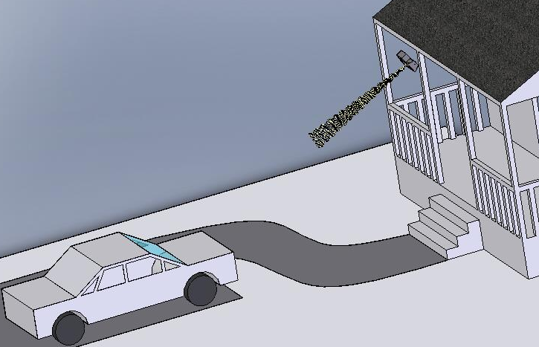 | Design Objectives  This device must be able to remove a thick layer of frost (1/8”) or thin layer of snow from a car windshield. The final design must be operated remotely at a distance of 20’ from the car. People without technical skills must be able to easily operate the device. The final design must have a low environmental impact.  Design Requirements  It was necessary to ensure the delivery of the required energy to melt the frost on the windshield. Through a series of calculations it was determined that 76 watts would need to be delivered to the square foot of windshield (Rep. 4.1.2). This meant that the infrared element used would need to provide enough power to overcome all losses in the system to deliver this energy. The reflective shield would reduce losses by focusing the infrared light beams that would otherwise be lost to the surroundings. The comparison of the bulb with and without the reflector from the same distance showed a 380% increase in concentrated light output (Rep. 4.2.2).

Design Concepts Considered
A medium wave infrared element was chosen for this design from the possible choices of types of radiation. The element used was determined to be of the quartz lamp type through an analysis of the specifications of other medium wave elements. | It was determined early in the design development process that some form of radiation would be used to transfer the energy from a remote source to the target 20’ away. It was decided that infrared radiation would be best suited for this design because of its high performance and high levels of safety seen in many common heating devices currently on the market (Rep. 3.2). The desired wavelength within the infrared spectrum was determined. An examination of the emissivity of ice showed that the best rates of absorption resulted in the wavelength range of 4 to 10μm (Rep. 3.2.1.). The infrared spectrum shows that the highest intensity in this wavelength range comes from a medium wave source.  There were a number of elements that offered different benefits and disadvantages. A decision matrix was used to examine these advantages and disadvantages (Rep. 4). While the matrix showed the quartz lamp and ceramic emitters to be suitable for the design requirements, the ceramic emitters had drawbacks. First the ceramic emitter offered was not easily found in a tubular shape, which was necessary for our design. It has significantly lower operating temperatures than those of the quartz lamps. A quartz lamp fits the proposed design and emits in a 360-degree pattern as required by the proposed prototype design. Therefore, the quartz lamp was chosen as the element used in the final prototype that was built.

Recommended Design Concept
The recommended design uses infrared radiation that is focused by a parabolic reflective shield. Heat transfer calculations were used to determine the energy required to melt the frost, and a scale model was used to find the focusing factor of the reflective shield.  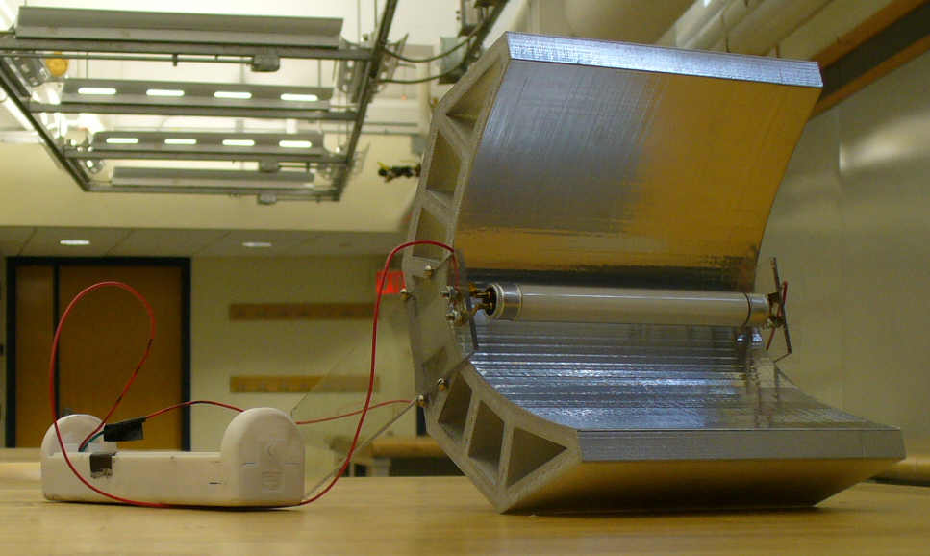  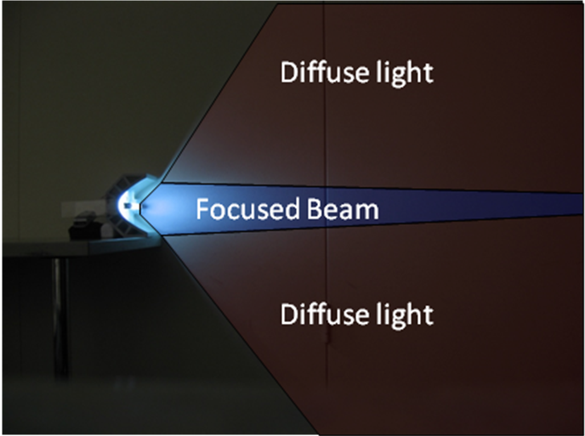 | Design Description  The final design of the windshield defroster uses infrared radiation to heat the car windshield from a distance. The radiation emitted will be focused using a parabolic reflective shield, and aimed towards the location in which a car is parked. This device will be mounted to the side of the house which will allow for the device to be more powerful as well as safer and more convenient to use.  It is possible to melt the frost from a distance while creating a device that had a high ease of operation by using a form of radiant heat. This required an in depth analysis of the energy required to melt the ice and the creation of a focusing apparatus to reduce the loss from the heating element in order to have a low environmental impact.  Analytical Investigations  After deciding the infrared spectrum would be used to accomplish the goal, numerous calculations were performed to determine the wattage required in the element to melt the frost. In doing this, view factor calculations were performed from all aspects of the system; the ground, the sky, the windshield, and the house (Rep. 4.1). With this data, an energy balance was used which was then solved for the wattage of the beam.  In order to optimize the product, a Solidworks model of the reflector was created where the focal point and distance from the windshield were fixed and the greatest use of the emitted radiation was taken into account to reduce losses. (Rep. 4.1.3)  Experimental Investigations  A scale model of the reflector was created on the rapid prototype machine to demonstrate the validity of the Solidworks model, and determine the focusing factor of the reflective shield. A fluorescent tube lamp was used with the scale model instead of an infrared element due to the emission of diffuse visible light instead of infrared light that would be invisible. The visible and non-visible sources would emit light waves that would perform the same in the test. This allowed the study of the ability to direct a focus and account for any losses in a physical setting. (Rep. 4.2.1)  With this scale model, the group was able to determine the effectiveness of the reflector using a photometer against a fixed area and comparing surface charts that were generated from the data. Tests were taken over both long and short distances and also with and without the reflector. (Rep. 4.2.2)  Key Advantages of Recommended Concept  This concept will allow the user to easily and efficiently defrost their windshield on cold mornings without causing unnecessary harm to the environment or wasting fuel. When compared to other options, infrared radiation at the medium-wave spectrum is optimal for melting ice (Rep. 3.2.1).

Financial Issues
The goal in this iteration was to make a working device that could also be made at a competitive cost to current solutions. The group targeted spending less than $1,000.00 on prototype development. | The principle financial issue of concern for the group is the ultimate cost of the product for the end user. If the product does not win in a costs-benefits analysis when compared to a competitor’s defrosting strategy, it will fail in the market and will not be a profitable concept. Therefore, it was necessary to consider costs in all decisions about the use of technology and materials.  In creating the prototype, however, a greater priority was placed in making the product work correctly and to the expected specifications to be sure the product was feasible. The goal of the group was to spend less than $1,000.00 developing the prototype and the group has met that goal, using only $618.23 to date. With this knowledge of a working product, studies may be conducted to reduce the costs of manufacturing for the end user.

Recommended Improvements
It is recommended that research be done to make the system more automated and efficient. | Key changes in the design that the group recommends include the installation of possible remote sensors to the device along with a motor assembly to better automate the system. Additionally, the group aspires to continue development on the curvature of the reflector to better concentrate the beam to make it more efficient and take less time to perform its function This added benefit will aid the users greatly in the areas of ease of use and performance.

