SMALL WIND POWERED GENERATOR

Design Team
Brian Klimm, Peter Ozols,
Tapan Patel, Jeff Walsh,
Dan West

Design Advisor

Prof. Taslim

Abstract
Wind powered generators are a growing source of renewable energy that can ease a consumer’s reliance on traditional power sources. Power harvested from wind produces no pollutants unlike the greenhouse gas emissions that come from the combustion of fossil fuels. Leading the way are wind farms consisting of a series of large wind turbines that each generate megawatts of power. There is also a significant market for smaller, household-size wind turbines that generate less than 10 KW. Prepackaged small wind powered generators can be installed by consumers to reduce or replace the need for connecting to the electrical power grid. The system being designed will be able to power a small home or cabin that is off the main power grid. The system will be able to support a building which consumes about 10 kWh of electricity per day. The wind powered generator will be able to perform at a low rpm range as well as at high wind speeds. The storage system will store enough power for 3 days without sufficient wind. The design consists of a horizontal-axis configuration which has the main rotor shaft and electrical generator at the top of a tower and is pointed directly into the wind. The direction of the wind generator is controlled by a simple wind vane. A 7 ft diameter rotor comprised of 3 blades will turn a permanent magnet alternator mounted horizontally. This will charge a battery bank which stores at least 500 Amp hours at 48 V. A sine wave inverter with a maximum rating of 3000 W will use this battery bank to provide 110 Volts Root Mean Square (RMS) to the cabin.
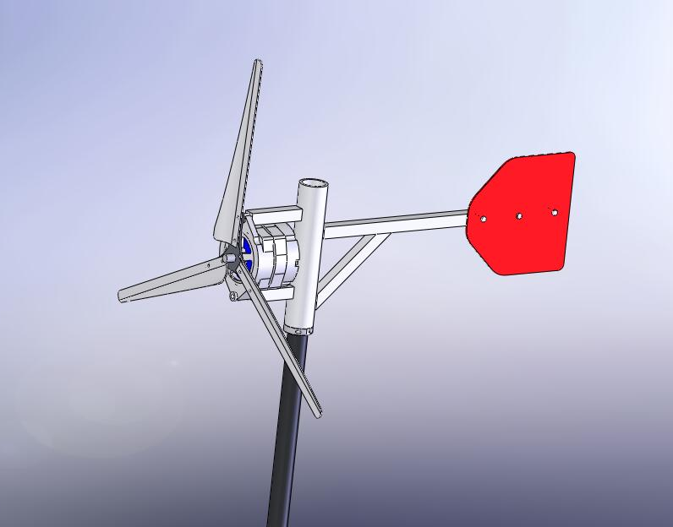
The Need for Project

The purpose of this project is to supply a wind powered system with the ability to store energy. | In this day and age, there is an increased emphasis on living an environmentally conscious life by using alternative energy. For every 1 kWh produced by a generator, an equivalent value of 3.41 cubic feet of natural gas or 0.0034 gallons of oil are preserved. The wind powered system detailed below will provide an alternative energy source to an off the grid location. Although there are currently many wind powered alternatives on the market, this particular system is innovative for its compact design that is capable of storing power in a battery backup system for continued use of up to 3 days without recharging.
The Design Project Objectives and Requirements
The primary objective is to charge enough battery power to maintain a small cabin for 3 days without wind. | Design Objectives  The primary goal of this project is to design a small wind powered generator that is capable of creating enough battery power to maintain a small cabin for 3 days without sufficient wind. This wind system will be for a cabin that is independent of the electric power grid.  Design Requirements  A wind powered system is comprised of a number of components working together to convert wind energy to usable electricity. These components must be selected to perform together and match the customer’s needs. A suitable location for the wind powered generator must be determined based on average wind speeds and regional regulations. The wind powered generator needs to power a cabin requiring an average of 10 kWh per day. The alternator needs to have a relatively low start-up speed to begin generating power from the wind. The power storage system will be able to provide 500 Amp hours electricity at 48 Volts which will power the cabin for 3 days without wind. The tower height and footprint are limited by local laws and regulations.
Design Concepts Considered
Each component in the wind powered generator design was evaluated and selected based on readily available market options.  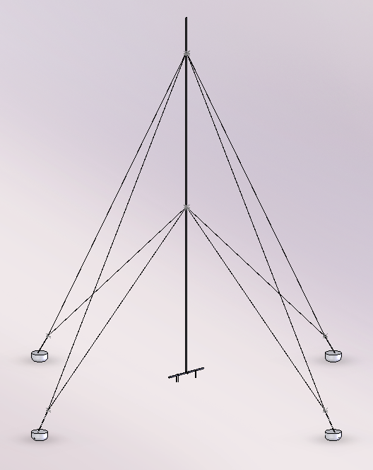  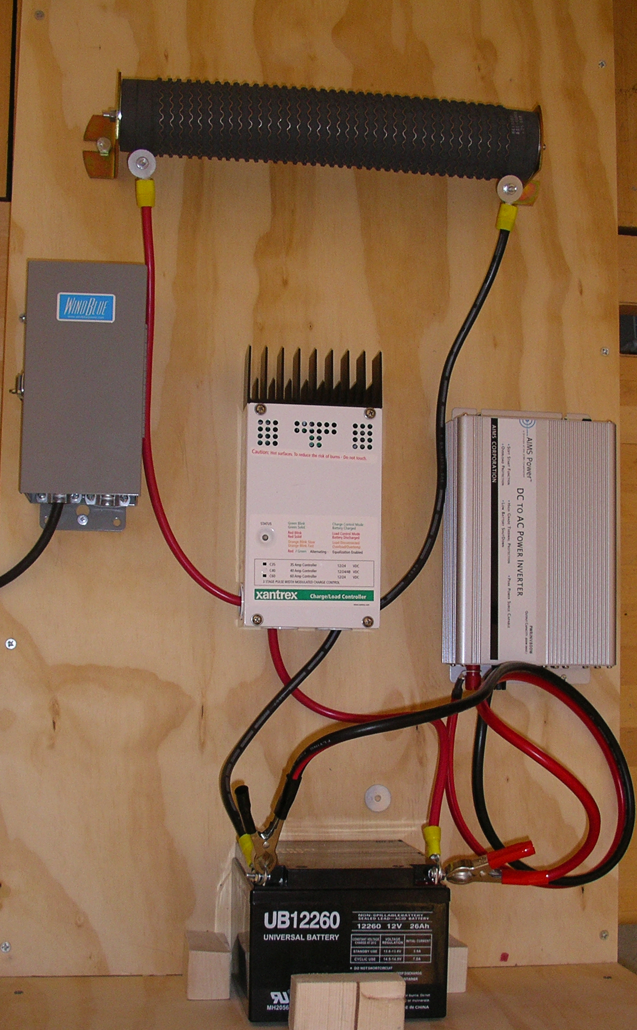  Dump Load Resistor  DC to 110V  RMS Inverter  Charge Controller  AC to DC  Rectifier  Prototype Electrical System  Battery | Locations Considered For Design  Wind power is a regional resource and is not economically feasible for every location. Potential sites were selected based on average wind speed, local regulations, and proximity to Northeastern. After looking at these criteria, the site was narrowed down to 3 locations: Nantucket, MA, Cape Cod, MA, and the NUHOC Lodge in Shelburne, NH.  Analysis of average wind speed maps of the 3 locations showed that the NUHOC lodge did not have a high enough average wind speed to sustain a wind turbine. Due to prohibitive regulations on Cape Cod, the location was eliminated. The Nantucket location has a high average wind speed and local regulations are friendly to small scale alternative energy systems.  Structural Components  There are three main tower designs for supporting wind systems, monopole towers, guyed pole towers, and lattice towers. Monopole towers are primarily used for large scale wind turbines due to their strength; these are also the most costly towers out on the market. The guyed tower uses a thinner pole held in place by a number of support cables. These cost the least, but require a large footprint for the support cables. The lattice tower is built out of welded steel and needs a much smaller footprint of land. The lattice tower falls between the tubular and the guyed tower in price.  The next component to consider was a hub or free moving yaw mechinism, which allows the blades to move into position to capture the wind energy. This was finalized after looking at a few different factors. The function of this component is to hold the alternator and tail vane perpendicular to the tower, while allowing free rotation in the yaw plane. Factors associated with hub design include a safe way to mount the generator and a tail vane with enough surface area to effectively control the direction of the rotor.  Mechanical Components  In a wind powered system either a permanent magnet alternator or an induction motor are most efficient for creating electricity from the wind’s kinetic energy. An induction motor requires power to start turning and must be connected to the power grid. The motor will not start producing energy until the rotation of the blades exceeds the startup rotation of the motor. These types of motors are most commonly used in large scale wind farm applications. A permanent magnet alternator starts to generate power once it starts turning at a certain rpm. A permanent magnet alternator is ideal for small wind power systems due to its low rpm performance and its higher efficiency.  The principal factors in blade selection are the number of blades and the blade geometry. Fewer blades allow faster rotational speeds, but also require a higher wind speed to start rotation. A greater number of blades reduces the overall rotational speed, but requires lower wind speeds to start rotation. Three blades offers the best balance between rotational speed and wind needed to start. The geometry of wind turbine blades can be either an airfoil design or a drag design. The airfoil design uses lift and drag principles to generate lift on the blades while turning. This enables the blades to spin faster than the wind. Drag design blades are pushed by the wind into turning and are limited by the speed of the wind. Airfoil designs are used on large scale wind turbines while drag designs are used for small scale home turbines.  Electrical Components  The major power storage systems to choose from are a battery system or a hydrogen fuel cell system. Due to complexity and cost, a hydrogen fuel cell system is not yet an economical choice. A battery system made up of Lead Acid batteries combines a cheap battery choice with a simple electronic system to power a house.  The battery system was modeled so that it can take the 3-phase AC power from the alternator and rectify it to charge a system of DC Lead Acid batteries. The battery system is sized to the average amount of power that the house uses on average to ensure that the house will be powered even if the wind turbine is not turning. The DC battery power is then converted to 110 V RMS with an inverter that is sized according to the maximum amount of power that the house can use at any one time.
Recommended Design Concept
The overall design is a 3 blade turbine that is resting on a free-rotating hub atop a guyed tower. The power generated by the turbine is converted to storable DC power which is then converted to usable AC electricity. | Design Description  The proposed design for a small wind powered generator to support a cabin consists of a three blade rotor stationed upwind and passively directed in the wind by a tail vane. The rotor is connected directly to a permanent magnet alternator without the use of step up gearing. The output of the alternator is 3-phase wild AC that is rectified to DC current to charge a battery bank. A battery bank is used to deal with the fluctuating power output from the wind powered generator. The power is then inverted to 120 V, 60 Hz, alternating current that is supplied to the cabin. The hub sits atop a steel tube tower that is supported by guyed wires.  To ensure safety of electrical components, a breaker is in series with the rectifier leading to the battery system. A switch shorting the leads from the rectifier stops the alternator from turning in an emergency and for performing maintenance on the wind generator. A battery controller with a diversion load ensures that the charge level in the batteries does not go above the maximum rating as well as keeping a load on the alternator. The inverter is powered from the battery bank to created 120 V AC power for the house.  Analytical Investigations  Analysis was first done to estimate the power and energy output of a particular location given average wind speeds and terrain. Expected power usage by a small cabin was considered to determine the size of the wind powered generator. A value of 237.17 kWh per month was established. Secondary analysis was conducted to confirm the final design met the requirement as defined by the team.  Other factors considered were the stresses in the hub and tower as well as the deflection in the blades.  Experimental Investigations  A proof of concept model was made to confirm that the design could product useable AC power. Testing was conducted on the roof of the Snell Engineering Building at Northeastern University.  Key Advantages of Recommended Concept  The key advantage of this small wind powered generator is that it is an off the grid low-maintenance system that has the means for storing energy for 3 days of use when needed in low wind conditions.
Financial Issues
The overall wind powered generator system costs approximately $14,000.  The proof of concept prototype costs approximately $1,000. | Unlike conventional power sources, which have high overhead, extensive maintenance and constant need of a fuel source, wind energy can be argued to be more economical. With wind power, the majority of the costs are in materials and construction.  The cost of installing aboveground electric cables to remote areas can be as much as $10 per ft or close to $33,000 per km. In order to have the system pay for itself the user has to utilize the generator for approximately 10 years (Rep. 2.1).
Recommended Improvements
Analysis on blade and alternator efficiency should be performed. | Further investigation should be completed on blade and alternator efficiency. This data could be used to refine the system to create less noise while producing more power with less wind.

