Human Jaw Motion Simulator

Design Team
Bryan Galer, Nathaniel Hockenberry, James Maloof,
Mia Monte-Lowrey, Katelyn O’Donnell

Design Advisor

Prof. Sinan Muftu

Abstract

Creating a physical jaw simulator will enable the study of the jaw’s mechanical kinematics, dynamic loadings, joint thresholds, and joint degeneration. This knowledge could lead to the ability to test and improve current jaw prosthetics or to eventually understand and treat temporomandibular joint (TMJ) disease. The problems that exist in creating a realistic simulator are the unknown order, direction, and magnitude of muscle forces, the functions of the various ligaments, and the forces in the complex TMJ. This project has been broken down into stages, with the target of this first stage to simulate jaw closing. In order to accomplish this goal, three muscle groups are simulated symmetrically on each side of the jaw: the temporal, the masseter, and the lateral pterygoid muscles. Servo motors are used to act as the muscles. The TMJ naturally has a very low coefficient of friction; low friction material and lubricants are used to reduce friction as much as possible. The system control is position based using a LabVIEW interface, which will also monitor the forces required in each muscle group.
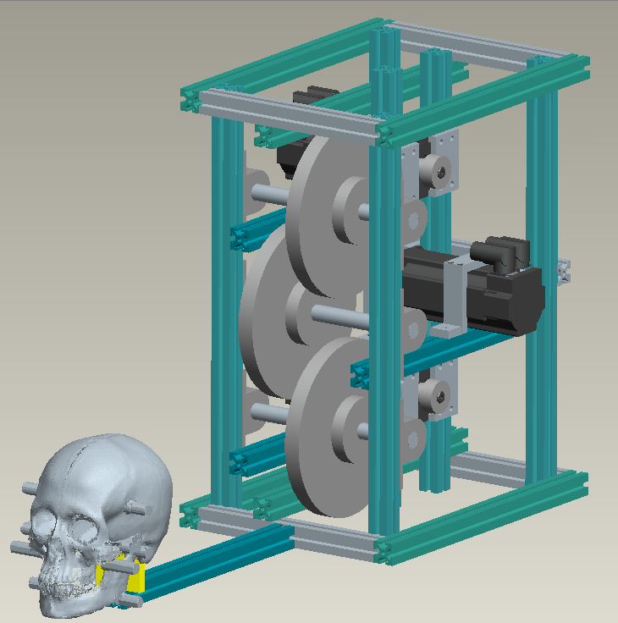

The Need for Project
The TMJ is a very misunderstood joint, a realistic mechanical simulation will help to analyze and treat jaw disorders. | The temporomandibular joint (TMJ) where the lower jaw (mandible) and the upper skull (maxilla) meet is a complex system. The left and right sides are not independent of one another, which complicates analyzing motion. Treatments for jaw disorders such as TMJ disease are still elementary. A life-like physical model is important to understanding the joint. Accurately representing the shape of the TMJ, the disc, muscles, and ligaments in a mechanical system will help to analyze forces and motions in the jaw, which will help to test treatments and jaw implants.  To create a thorough model it is necessary to break the project down into stages. The first stage will create the initial setup of the model, including a LabVIEW interface, and replicate closing motion simulating three muscle groups symmetrically on each side of the jaw. Future stages will add additional motions and details.
The Design Project Objectives and Requirements
The objective of this stage is to create closing motion in a physical skull using mechanically simulated muscles and a LabVIEW interface. | Design Objectives  The first stage of this project is to represent the closing motion of the jaw using mechanical simulations for three muscles on each side of the head. The design must include an accurate physical model of the skull and jaw, mechanically simulated muscles, and a LabVIEW interface to input and record data from the simulation.  Design Requirements  Studies have shown the maximum force in the temporal muscle acting on the TMJ produces 120 lbs (530 N). To close the jaw without resistance the force in all muscles is approximately 10% of the maximum value. Creating simulations with maximum forces is desired because the long term goal is to replicate chewing and clenching in the jaw.
Design Concepts considered
Various mechanical simulations, methods of obtaining a skull, and TMJ lubrications were all components of the design considered.  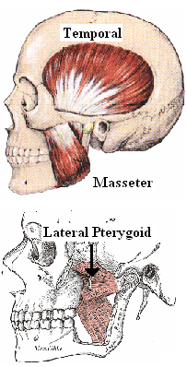 | In designing the simulation many options were considered. First, deciding which muscles to use was important. There are five main muscle groups working to close the jaw. In order to decrease this number to three, muscles that created repetitive forces were removed. Larger muscles such as the temporal muscle are often broken into segments for analysis, but to keep the simulation limited these will be simulated as one. The final muscle selection includes the temporal, masseter, and lateral pterygoid muscles.  Methods for creating the forces of the muscles were considered next. High precision motors, standard precision motors, pneumatics, hydraulics, air muscles, muscle wire and polymers were all considered. Based on control, precision, accuracy, complexity, available resources, safety and cost, standard precision motors were preferable. Of standard precision motors stepper, DC brushed, DC brushless, shunt, and series motors were all considered. DC brushless motors were selected for the project, because of their resistance to wear, ease of control and a variable torque dependent on the load. (See Report Section 2.3)  There were two main options in obtaining the skull. The first was to buy a prefabricated skull. The second was to obtain a computerized model of a skull and fabricate it. A computerized model of the skull was obtained, so that the exact surface of the TMJ could be accurately mapped for theoretical testing and to be used in creating the LabVIEW input. The computerized model allowed for muscle attachment points and mounting attachments to be built into the skull.  Initially a force input was considered as the method for controlling the motors. Due to the number of muscles and the unknown contact and muscle forces, a single solution could not be obtained. In order to circumvent this issue a positional control was designed to move the motors through predetermined steps. During this process the joint is assumed to move normal to the surface, and the program will record the forces needed by each of the motors to achieve the destination. (Rep. 3.1)  Low friction materials and tapes such as Delrin film, Teflon film, PTFE tape, Delrin stock, Teflon stock, and PTFE stock were ordered to be friction tested along with UniFlor lubricant. Combinations of the materials were tested. Currently the best result was using the Teflon tape with the lubricant resulting in a 0.06 coefficient of friction.

Recommended Design Concept
A frame holds three motors and their pulleys, which pull wires that are attached to the skull creating motion all controllable through LabVIEW.  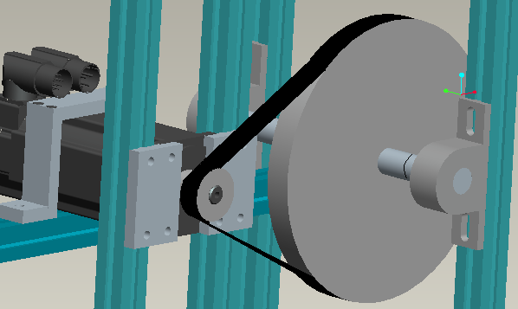  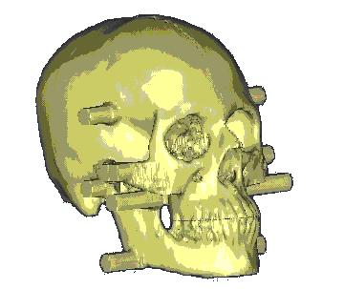  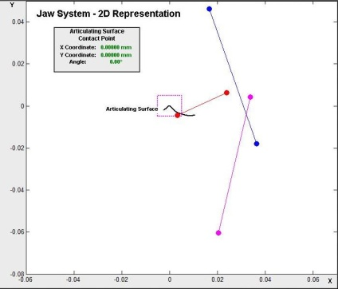  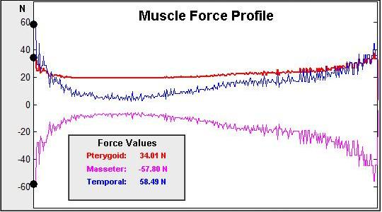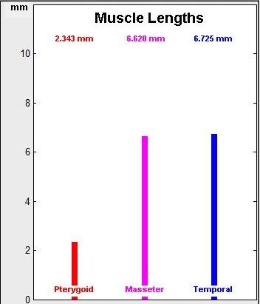 | Design Description  A 15” x 12” x 20” frame was built using extruded aluminum. To this frame three DC brushless servo motors were attached. Each motor is capable of producing 2.2 Nm and 680 rpm. Each motor has an encoder which allows its position to be tracked. A pulley attached on the motor shaft connects to a gearing pulley. The gearing pulley rotates a shaft that runs the length of the frame and is connected at each end with a bearing. On each end of the shaft is a bracket that holds a wire. The wire rests around its stationary anchor point on the upper skull and connects to the attachment point on the movable jaw.  At the front of the frame a projection was built. The skull is mounted to the projection by a plate through the back of the head.  The skull was designed with twelve projections, based on studies of where the muscles attach to the skull and jaw. The three projections on either side of the skull are called the anchor points. These projections are tapped to hold a 3/32” shoulder screw. The wire curves around this point to ensure that the force is always pulling from the same location. The three projections on either side of the jaw are the attachment points. Each attachment point is tapped to hold a 1/4” shoulder screw. A lubricated tube was placed around the shoulder with the wire attached. The tube allows movement to ensure that the wire is always pulling in a straight line from the anchor point.  The skull was a CT scan file edited using Mimics software. The skull and jaw were printed as two separate parts using an SLA machine. The skull was sent to US Surgical to be rubber molded out of polyurethane, to ensure that material would be strong, non-brittle and not directionally weak which are some of the problems with SLA and 3-D printing.  The motors and their encoders are connected to a three axis driver. The driver connects to the controller which communicates with the LabVIEW interface. National Instruments Motion Assistant was used to help create the virtual interface that controls the motors.  Analytical Investigations  The system was modeled and analyzed in two dimensional space. The attachment and anchor points were created on the same plane in order to simplify the calculations and accommodate the design assumptions. A virtual simulation was created using Matlab in order to assist in calculations and to validate the assumptions. All design constraints including the location of attachment and anchor points, coefficient of friction, model mass properties, and the shape of the articulating surface can be input into the simulation. The program determines the motion of each of the attachment points based on the assumption that the orientation of the mandible is always perpendicular to the slope of the articulating surface at the contact point on the mandible. The program also calculates the theoretical forces generated by each muscle based on the assumption that the disc experiences a constant compressive force. Since the disc is responsible for maintaining the orientation of the mandible it has been left out of the model. The compressive force is represented as a normal force from the articulating surface.  Key Advantages of Recommended Concept  The major advantage of the design is its versatility. The frame is made of extruded aluminum, allowing for each component to be adjusted, in the case that something needs to be modified. The LabVIEW interface takes an input file of positions, which can be easily changed to allow for updating of the path of the system. The Matlab program that analyzes the motion of the system is easy to update in order to accommodate changes. Since the forces of the system are indeterminate using equations, the positional input and LabVIEW allows for the forces required by each motor to be monitored.
Financial Issues
The design cost $12,000.00. | The current design including: motors, driver, controller, fame and hardware, and Mimics software cost approximately $12,000. The project is not designed as a consumer project. It is to be used as a research device. The healthcare costs associated with TMJ disease is much higher than this initial cost.

Recommended Improvements
Additional muscles groups, motions, and details will be added in future stages. | The project was created with the intention that future work will be done to add more muscle groups and features. Opening, side to side motion and clenching are important. Further advancement to the project would include eliminating the attachment and anchor points created as projections and instead following the non-planar muscle paths. Adding more muscle groups and dividing the current groups into more parts would make the simulation even more accurate. The temporal muscle is represented in this stage by a single motor; future versions would have the temporal muscle represented by two or three positions.

