Sterilization Device for Liquid Chromatography Solvents

Design Team
Nicolas Roulleau, Michael Vose
Michael Racette, Michael McKay

Design Advisor

Prof. Mohammad E. Taslim

Abstract
Advances in liquid chromatography systems, which allow increases in the speed and resolving power of chemical analysis, have been made possible by reducing the size of critical components in the analytical column. These improvements have led to an increased risk of clogging and premature failure of the columns due to microbial growth which is carried into the column in the aqueous solvents used in the test procedures. A device for reducing the likelihood of mechanical failure due to clogging is needed. The prototype designed to treat stagnant aqueous solutions used in chromatography consists of a filtration and ultraviolet sterilization system which inactivates microbes and continuously filters the liquid to remove sterilized bacteria and debris. Proof-of-principle testing is underway to demonstrate the expected decrease in clog rate of the analytical columns.
Ultraviolet Block
Electrical Components
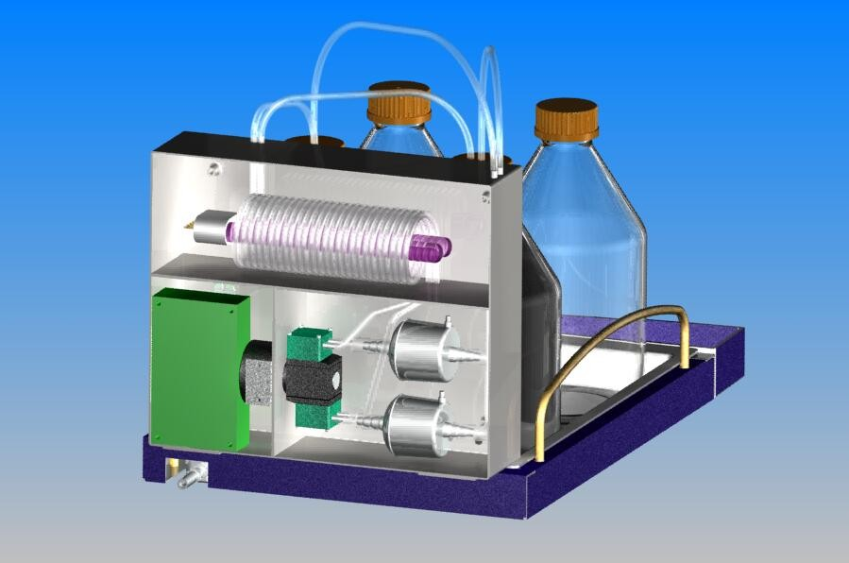
Filters
Dual-Head Pump

The Need for Project
A solution will enable further advances in chromatography technology by reducing the potential for mechanical failure of the column from bacterial clogging.  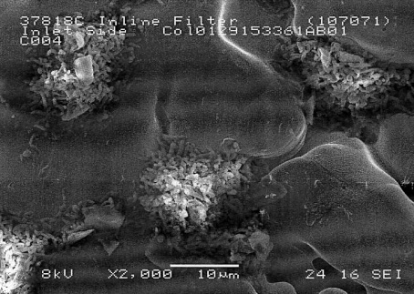  Bacterial Clogging of Metal Frit | Waters Corporation has created the ACQUITY chromatography system to enable chemists involved in the fields of pharmaceuticals, forensics and other important industries, to reduce the time and increase the resolution of compound analysis. Chromatography is an analytical process where compounds are pumped through a channel packed with chemically-active particles. As the compound is pushed through, separation of the compound into its constituents occurs, based on the affinity of these constituents to the particles. At the outlet, the individual chemicals are detected and quantified. The ACQUITY system has delivered ultra-high resolution and speed to this process by reducing the size of the particles inside the column. In some cases, Water's customers have experienced unexpectedly short column life compared to older columns packed with larger particles. It has been determined that a cause of these failures is bacterial growth in the aqueous fluids used in these tests. Waters seeks a solution which enables further gains in efficiency, speed, and resolution in their column technology through further particle size reduction, and maintains the reliability of their product by reducing the potential for mechanical failure of the column from bacterial clogging.
The Design Project Objectives and Requirements
The primary objective is to extend the expected useful life of chromatography columns. | Design Objectives  The primary objective is to extend the expected useful life of chromatography columns. In doing so, it is required that the solution be adaptable for worldwide use, and that it consider applicable regulatory standards (Rep. 5.2). Finally, the device must require minimal end-user intervention or maintenance.  Design Requirements  Specific acceptance criteria for the design solution include that the column life be expected to exceed 1000 injections. Each component in the design must be expected to remain maintenance-free between annual preventative maintenance visits. No detectable change in the chemistry is acceptable. To ensure this, the system must not cause a change in pH, nor can it introduce any new impurities greater than one part per million. Lastly, the solution must be capable of treating two bottles simultaneously, and must be adaptable to bottle sizes from one to four liters, which are commonly used in chromatography.
Design Concepts Considered
The most promising candidates for controlling bacteria in the solvent bottles were sonication, filtration, and ultraviolet light.  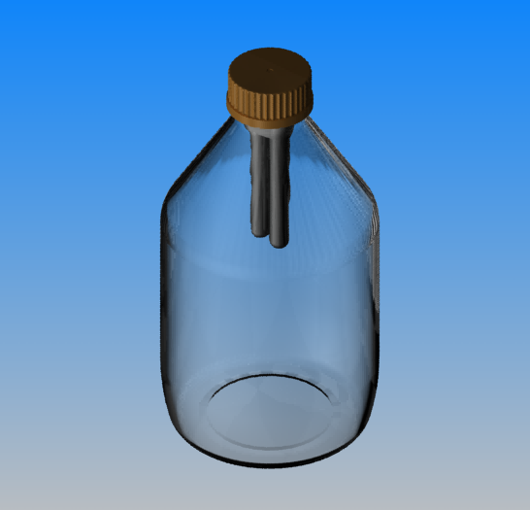  UV  Probe  Ultraviolet Probe Concept  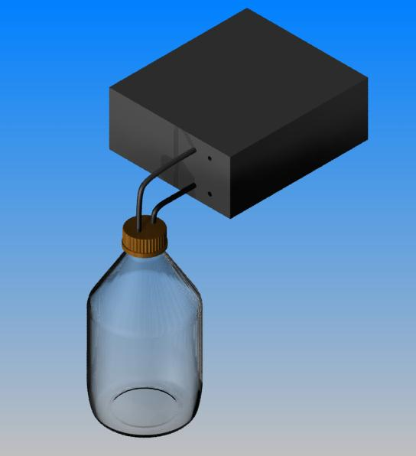  External Filtration Concept  Filter  and  Pump | Three general concepts that did not violate the design requirements were selected from an initial list of 15. The most promising candidates for means of controlling bacteria in the solvent bottles were sonication, filtration, and ultraviolet light. (Rep 6.2)  Sonication  Ultrasonic energy in cell disruption is often used in biotechnology for cell disruption and homogenization. This concept would consist of an ultrasonic probe mounted through a bottle cap which would be height adjustable for different bottle sizes. This concept was not selected for development because debris from disrupted cells would still be problematic, and the ultrasonic energy could volatilize some of the chemical additives in the liquids to be treated. (Rep 6.2)  Ultraviolet Radiation  Ultraviolet (UV) light is used commercially in germicidal applications from hospital air treatment to water purification, and is effective in treating nearly all common species. Several design concepts which employ UV to sterilize the liquids were discussed. One concept was a hermetically-sealed UV probe which could be mounted to the bottom of the bottle cap, and inserted into the bottle. This system would effectively kill bacteria residing in the bottle, but would not ultimately remove the bacteria from solution which would still eventually clog the column inlet.  Filtration  Filtration is the most frequently used and among the best characterized method of purification of liquids. Two concepts that used filtration were considered. One design would incorporate a micro-pump and small filter incorporated into a bottle-cap assembly to continuously recirculate the fluid through the filter. This option was not pursued after it was found that the worst-case bacteria counts would exceed the capacity of a sufficiently small filter.  An external filtration system was explored incorporating filters large enough to contain bacteria accumulated over the year between preventative maintenance visits. Based on analysis, it was clear that filtration alone could not last a year without user intervention if the bacteria were allowed to grow on the filter membrane, and that a combination of sterilization and filtration would be required.
Recommended Design Concept
A system which incorporates UV sterilization with removal of inactivated bacteria and debris by filtration is the best design solution  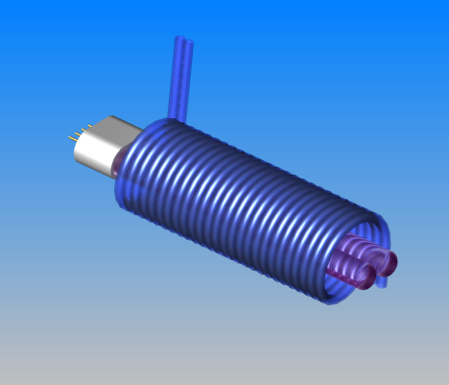  Ultraviolet Lamp  Dual  FEP  Coils  Ultraviolet System  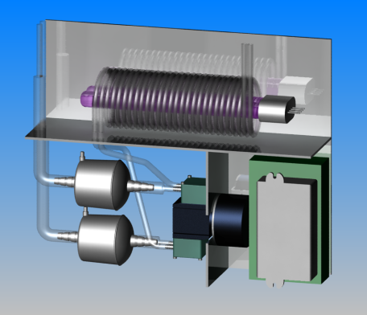  Filters  UV  Pump  Critical Components | Design Description  The recommended design combines filtration for the removal of bacteria and debris that could clog the column, and an ultraviolet system for inactivating microbes that would quickly clog the filter if left to multiply. The final design uses a dual-head mini-pump to drive parallel sterilization lines to treat two bottles simultaneously. Water drawn from each bottle first passes through a UV treatment block, where sufficient energy is delivered to inactivate 99.99% of even the most persistent bacteria. After sterilization, the fluid passes through the pump and into a filter to remove dead bacteria and debris, and is recycled into the bottle. Continuous operation ensures that any microbe that finds its way into the bottle will be inactivated and filtered before it can regenerate.  Analytical Investigations  Three main analyses were required in specifying system components (Rep 8.2.1). First, it was necessary to establish the effective filter area that would be required to provide maintenance-free service for one year. With no bacterial replication, the filter capacity that would be required was determined to be about 85cm². Filters were selected based on the chemical compatibility of the membrane and housing, and the availability in sufficient capacity. A hydrophilic, 200cm² capsule filter from Pall Corporation was selected and is expected to provide ample capacity and to be chemically inert.  Second, Darcy's Equation for porous media was used to determine pump pressure requirements for driving the flow through the filter as the filter area is reduced by clogging. A brushless-DC, dual-head pump capable of up to 15psi was selected which has an expected continuous operation life of 10,000 hours, which meets the annual maintenance target.  Finally, the ultraviolet block consists of an 18W compact fluorescent lamp powered by a universal ballast, compatible with input voltages and frequencies anywhere in the world. Using a view factor method, the irradiance profile around the bulb was determined, and the dose that each particle will receive during the time it takes to pass along the flow path in close proximity to the lamp was calculated. Since a linear fluid path was found to be insufficient, a new analysis was developed to determine that the dosage for a fluid path which spirals around the lamp 13 times provides more than the minimum required dose.  Key Advantages of Recommended Concept  This design incorporates two sterilization lines in a package which is unobtrusive, does not interface with the main system, and requires minimal user intervention. Because the fluid is sterilized, then filtered, the system will not require frequent service. The system runs continuously to reduce the rate of clogging of chromatography columns, and should save the end-user significant instrument down-time, as well as material costs.
Financial Issues
Production cost targets are attainable, and conservative estimates for user savings suggest the product will be very marketable. | Prototyping costs to date are less than $700. Waters has suggested that a good target production price is around $500. Based on initial estimates, it is likely that production costs, including assembly and testing, would not exceed this target. The material costs for column replacement is $300-$500, excluding instrument down-time, operator costs, or other "soft" factors. Cost analysis has determined that annual column cost savings to the end user would be between $600 and $44,000.
Recommended Improvements
This device will require further testing to ensure that design specifications that could not be tested during prototyping have been met. | Further testing and development tasks should be conducted to test the functionality of the UV system using microbiological test methods, to confirm in real-time that the projected filter life of more than one year is attained, and to demonstrate that the device does not impact the analysis by introducing impurities or other detectable changes. Refinements are recommended to the enclosure to  Further refinement of the device may be desired if it is determined that the size is undesirable. The pump size can likely be reduced without impact, provided it provides sufficient pressure to drive the flow. Filter size could be reduced if supported by real-time life data, and provided the cost of custom-sized filters can be negotiated. These changes are not likely to improve the performance, but could reduce the footprint of the device. Finally, verification and validation will be required prior to commercialization.

