Fruit Picker

Design Team
Dwight Aberle, Jared Baggen, Derek Donahue, Ryan Hennessy, Stephen Mathras

Design Advisor

Prof. Taslim

Abstract
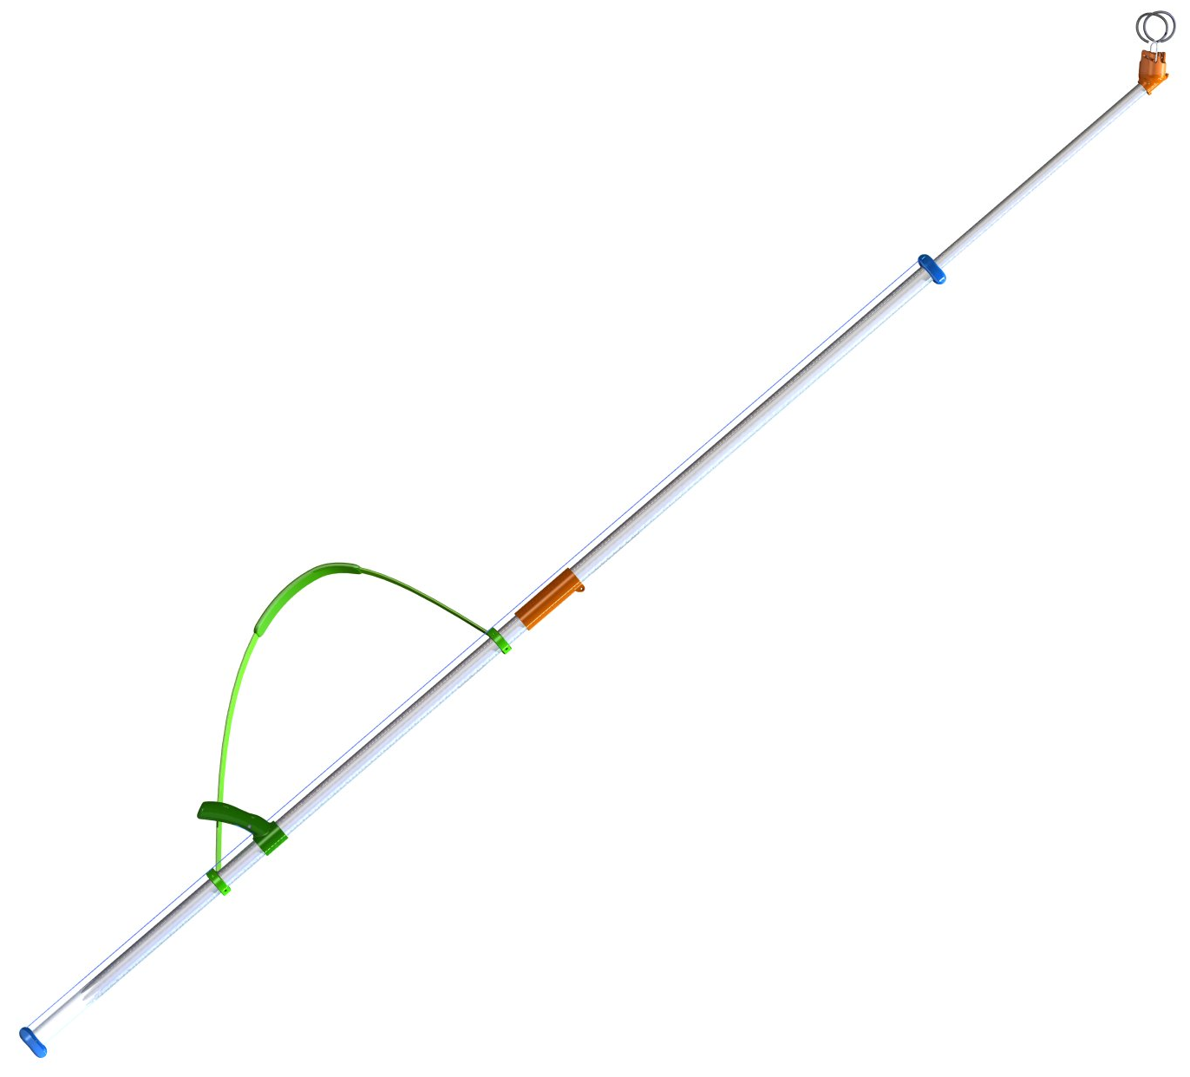
A new method for picking fruit on small scale farms or for personal use has been engineered for this Capstone project. Current pole mounted pickers cause strain in the user, are difficult to manipulate, and can permanently damage the tree. Evaluation of purchased commercial devices and multiple orchard visits provided insight into all aspects of fruit picking and, consequently, the goundwork design focus. The results of this project include the conceptual designs and prototypes for two devices, both of which include subassemblies for the gripping and twisting of the fruit, actuation of the gripper/twister, and continuous pole length adjustability. They are lightweight & maneuverable, allow the user to manipulate the device numerous times at varying heights with minimal strain, and reduce the potential for permanent tree damage.

The Need for Project

Current methods of picking fruit higher than hand reach are dangerous, uncomfortable, and harmful to the tree.  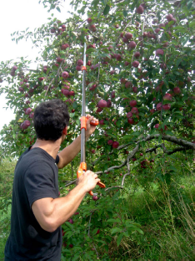 | For small farms and homeowners with apple (or similar) trees, there is a need for a comfortable and easy to use fruit picker. Current products are cumbersome, difficult to use, and can damage the tree while picking.  This project also has relevance for many pick-your-own orchards. Insurance restrictions often prevent orchards from allowing patrons to use ladders to pick fruit that grows out of hand reach. For full scale harvesting at an orchard, workers climb specially designed ladders and pick fruit by hand, which is by far the fastest and most benign (with respect to the fruit and the tree) way to pick fruit. However, these ladders are impractical and unsafe for homeowners.
The Design Project Objectives and Requirements
To design and build a prototype of a device enables a user to pick fruit that is out of hand reach (apples and other similar fruit) in an easy, safe, and effective manner.  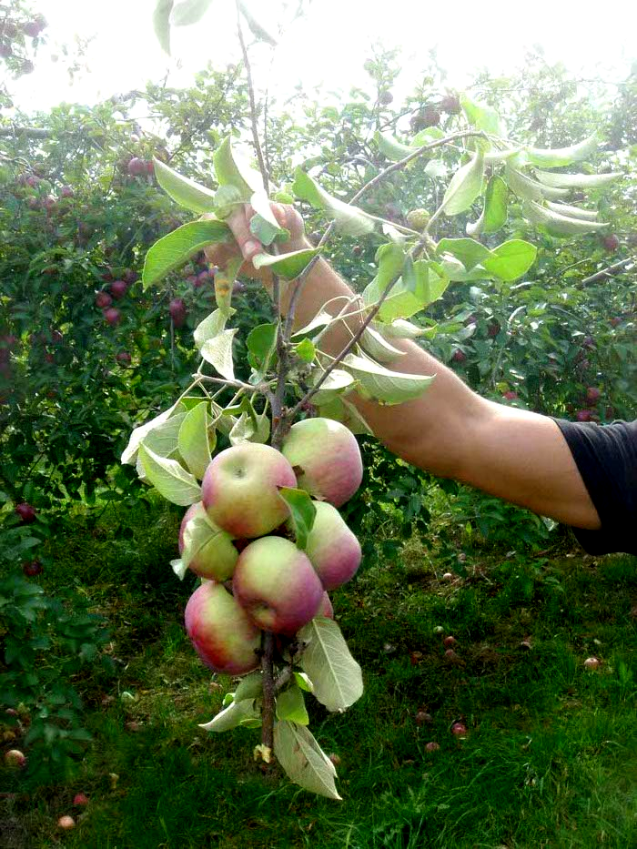 | Design Objectives  To design and build a prototype of a device that enables a user to pick fruit (apples and other similar fruit) that is out of hand reach in an easy, safe, and effective manner.  Design Requirements  The device must allow the user to access all of the fruit on a tree of up to 15 feet in height. The user should be able to easily maneuver the picker through tree branches and leaves, as well as safely pick fruit that grows in tight clusters. Furthermore, to prevent damage to the spur (fruit bearing branch of a fruit tree), a twisting motion must be employed to detach the fruit. This twisting motion will require no more than 180 degrees of rotation to successfully remove the fruit’s stem from the spur of the tree.  To reduce physical strain on the user, an ‘on-the-fly’ adjustment system must be integrated that allows the user to rapidly change the height of the device while remaining in a consistent picking position.
Design Concepts considered
A hand-like head and twisting ramp have been considered and prototyped.  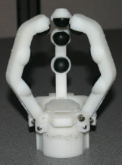  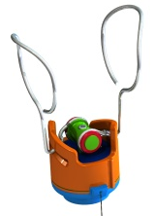 | From the design requirements, three major areas of concepts have been seriously considered: the head (part that interacts with fruit), adjustability, and actuation. While many concepts have been considered in brainstorming, those listed below represent the serious ideas that fit within a specific set of constraints determined by research.  Adjustability  Two telescoping poles are incorporated into all of the design concepts. Using two poles with space between the larger bottom pole and the smaller (diameter) top pole, two concepts of continuous adjustment have been considered. One involves a loop of string that rigidly connects to the inside pole, and is routed along the outside pole, where the user can engage the string. The second concept employs a single string that is also rigidly connected to the inside pole, is routed to the user on the outside of the pole, but then travels inside the inner pole to the head. This concept addresses both actuation and adjustment, but as a result, is in conflict with other design requirements.  Actuation  Using string/cable connected to the picking head, two main actuation concepts have been developed. One involves a spring-wound drum that automatically releases and recoils string during adjustment, which locks to allow actuation. The second is a string that rigidly connects to the inside pole, is routed outside to the upper hand of the user, and finally attaches to the picking head.  Head  Two major head concepts have been developed. One consists of three finger-like arms that close around a piece of fruit when the actuation string is pulled. Springs in this design can be reversed to allow the fingers to open when the actuation string is pulled. The second concept involves unique ramp geometry that enables the head to close onto a piece of fruit and then twist, with a single pull of the actuation string.

Recommended Design Concept
The recommended concept features an innovative telescoping pole and a fruit picking head that employs rotation to remove fruit.  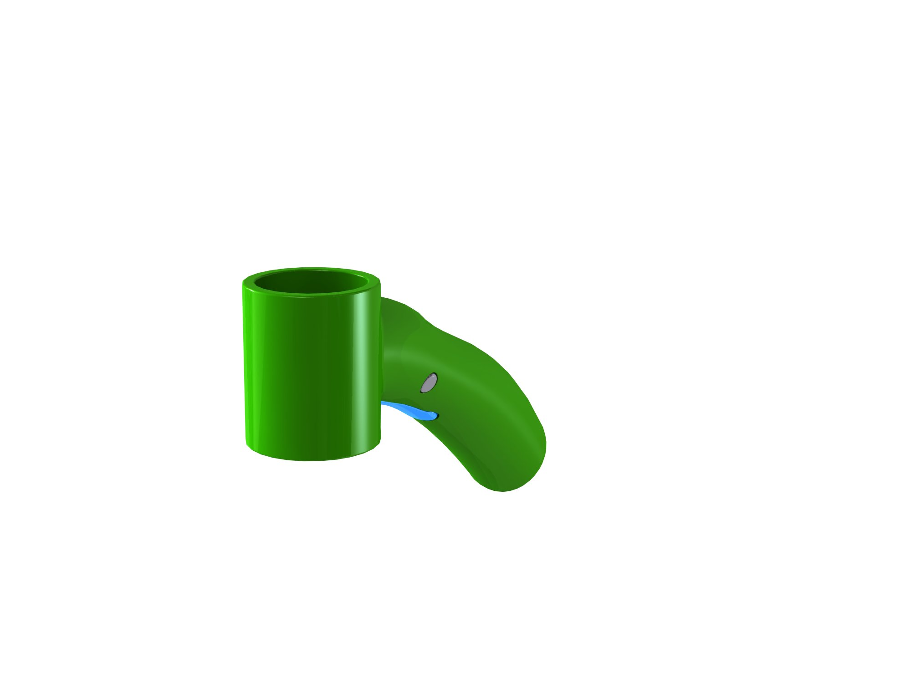  Lock handle  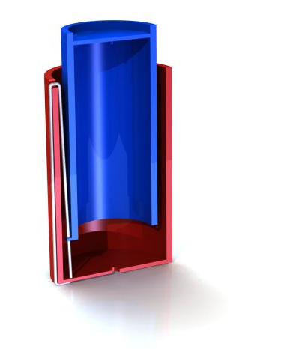  Inner Pole  Outer Pole  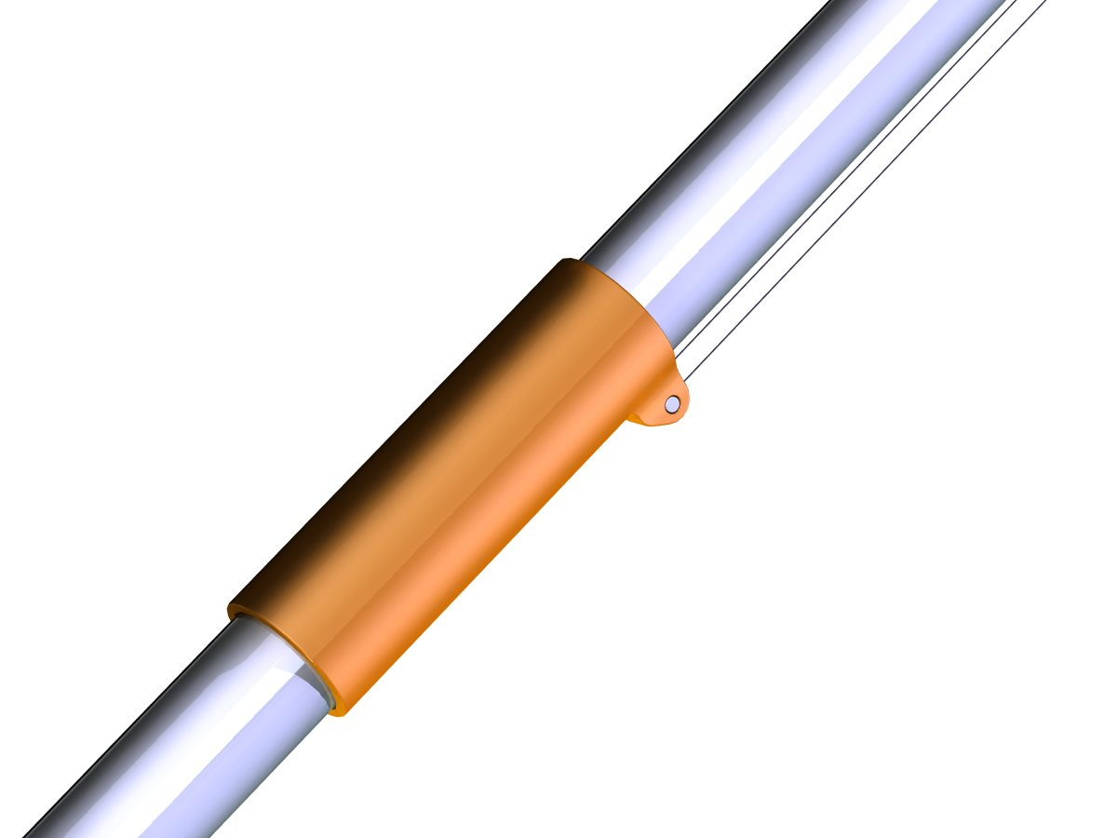  Actuation Handle  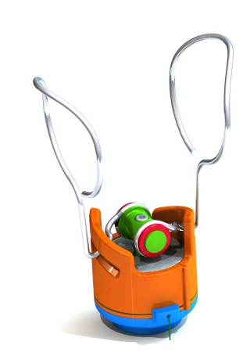  Ramp Head Concept | Design Descriptions  Of the concepts considered, one from each of the three main design categories was chosen based on inter-compatibility and initial design requirements  Adjustability  The recommended adjustment method is the string loop that allows the user to continuously adjust the pole length from a consistent picking position. This is accomplished by a loop of string attached to a spacer at the bottom of the inner pole. Pulling down on the string results in the pole extending, and pulling up results in the pole retracting.  Beyond the basic concept, the features of this design include caps on both ends of the bottom pole that provide a smooth radius on which the string can slide. These help not only to reduce friction in the system, but also to provide bearing surfaces for the two poles. Another critical component of this design is a bottom-hand string lock, which is incorporated into a handle. This lock prevents the weight of the top pole from causing the poles to involuntarily retract. The lock, engaged by default, can be unlocked with the index finger without removing the bottom hand from the handle.  Actuation  A retracting drum concept was discarded in an attempt to simplify user interaction and to reduce overall part count and component complexity. The recommended actuation concept is a string that rigidly connects to a bottom spacer of the inner pole, and is routed to a handle near the user’s upper hand before attaching to the head. Since the adjustability lock is engaged by default, pulling this string downward provides the force required to actuate the head.  Head  The recommended head uses innovative “ramp” geometry to produce a grabbing and twisting motion, consecutively activated by a continuous pull on the actuation string. As the string is pulled, the slotted ramp begins to rotate. This causes the arms of the head to close in around the fruit. When the arms engage the fruit to a design-controlled force, the arms spin with the rotation ramp, safely twisting the fruit from the tree. This concept is recommended due to its functional superiority over the finger-like head concept. Unlike the finger concept that requires the user to actuate the head, then physically twist the pole (causing complications throughout other systems), the ramp concept grabs and twists the fruit with a single, continuous pull of the actuation string. This simplifies the user interaction and allows other subassemblies to have definite orientations.  Analytical Investigations  Finite element analysis on the telescoping pole provided data on which to base material selections.  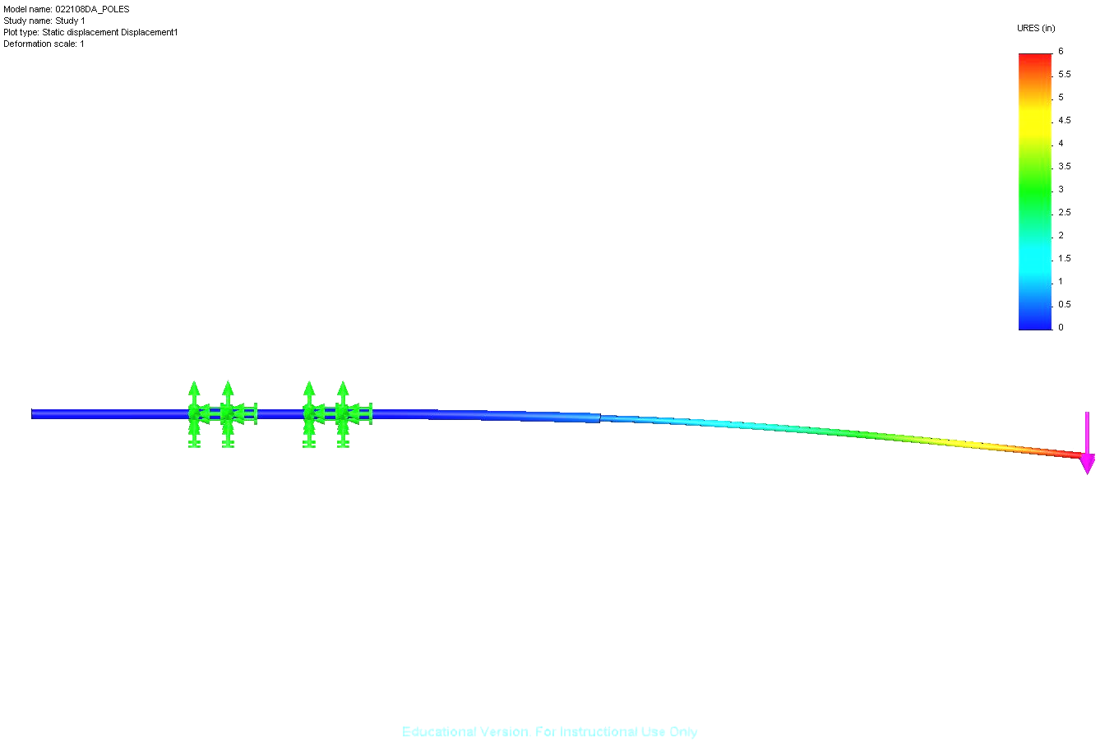  In order to improve upon the comfort of existing fruit pickers, preliminary ergonomic testing has been completed using a strap to distribute the product’s weight from the user’s arms to his/her torso. This design is easily implemented into the picker as a result of the stationary orientation of the bottom pole, achieved through the strategic design of other picker components.  Prior to designing the twisting mechanism, the torque necessary to separate the stem from the fruit was determined. This information has been used to evaluate the forces required to capture and twist a piece of fruit.  Experimental Investigations  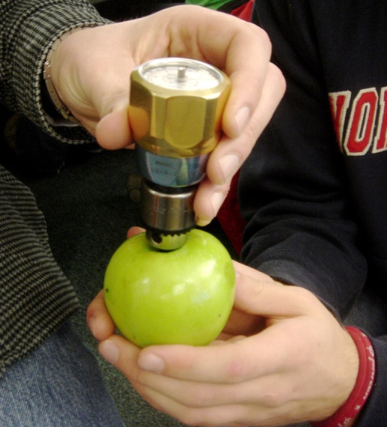  The torque necessary to separate the fruit from the spur is considerably less than what is required to separate the stem from the fruit. By designing our twisting mechanism around the stem to fruit torque, we are designing to the worst-case scenario, and guaranteeing that we always be able to separate the fruit from the spur. Our measurements yielded an average torque of 5.0 oz-in.  Additionally, a friction test was developed to determine which durometer material had the greatest coefficient of static friction while grabbing a piece of fruit, for potential use in head designs.  A pull of the actuation string grabs and twists fruit. Pole length can be adjusted “on the fly” from the normal picking position.  Key Advantages of Recommended Concept  Comparing the prototype with existing products provides a meaningful comparison tool. Here, the prototype is compared to the popular Twister Picker.  Significant advantages presented by the prototype include simplification of user input with the single pull actuation system, letting the head determine the correct squeezing force and twisting the fruit off the tree. Allowing the user to remain in the picking position while adjusting pole length, compared to resting the device on the ground and moving out to change it, is another obvious improvement. Research determined users were more likely to alter the pole angle (relative to the ground) as an alternative to adjusting the length, so the new system promotes both higher picking efficiency and a more comfortable, safe experience.  Finally, the awkward and frustrating dangling activation string on the Twister Picker is replaced by one that stays taught and close to the pole automatically even when the pole length is changed. Other noteworthy modifications, non-essential to actual fruit removal but imperative for an enjoyable experience, include a shoulder strap and bottom handle. These allow for great control with only the bottom hand, leaving the top one to adjust and pick.
Financial Issues
Prototyping cost, excluding 3D printer costs, was $300. Final unit price is aimed to be approximately $50. | Utilization of an FDM rapid printer permitted quick and inexpensive concept turnaround of parts intended for injection molding or that would have been difficult to machine.  The production model of this prototype is intended for mass production. The intended cost of the two aluminum poles and several injection molded parts is approximately $50.
Recommended Improvements
Adding a collection method obviates manually delivering the fruit to the ground. | This project was intended to surpass currently available pickers in functionality and user interface. All identified issues were solved except delivery of picked fruit to the ground. Generated concepts were deemed too intrusive to the picking process itself, as they tended to become caught in surrounding branches, leaves, and fruit.

