Automation of Plasmid DNA Purification Process
Phase II

Design Team
Natalie Bloomhardt, Stefanie McGuckian,
Jeffrey Patenaude, David Schiavoni-Exman,
Zachary Withrow

Design Advisor

Jeffrey Ruberti, Ph.D.

Abstract
Our project provides a means to automate the purification process of plasmid DNA, by altering the mini-prep procedure from centrifugation to automated filtration. Phase I produced a filtration design yielded higher output and equivalent purity plasmid DNA than the centrifugation method. Phase II finalized the 96-thru-well filtration assembly and developed four automated stations that will clamp and pressurize, dispense dry filtration aid, dispense liquid reagents and mix the solutions. Testing was completed to verify the operability of each station. Optimization of the automated mini-prep using the newly developed stations can yield higher throughput, greater plasmid DNA purity, and reduced capital expenditures.

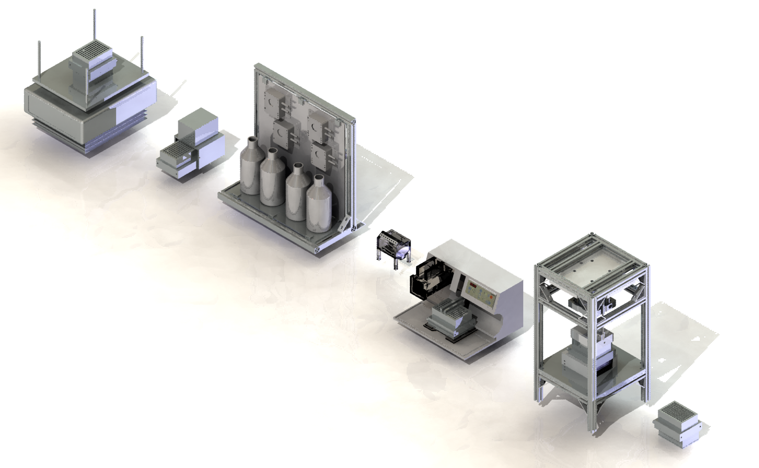

The Need for Project

This project reduced the time to purify Plasmid DNA, required for testing gene function, by 75%. | The need for this project is to produce large amounts of Plasmid DNA used to perform a genomic screen. A genomic screen requires 100,000 samples to analyze the effects of suppressing one gene. There are approximately 30,000 – 40,000 different genes in the human genome. Research on gene function has been hindered by the lack of high throughput of Plasmid DNA purification.  The current process which uses centrifugation takes approximately 64 minutes to produce 96 samples of Plasmid DNA. This project replaced centrifugation with positive pressure filtration and reduced the purification time by 75%. Additionally this project further optimized the process by allowing multiple 96-well plates to run concurrently.
The Design Project Objectives and Requirements
The objective was to design a fully automated system that can achieve a throughput of at least 10,000 samples per week with an equivalent purity produced by the standard mini-prep procedure which includes centrifugation. | Design Objectives  The overall objective of this project was to produce a system capable of processing a 96-well assembly in an effort to automate the purification of Plasmid DNA. It was important to increase throughput to 10,000 samples per week, maintain purity equivalent to centrifugation, reduce consumables, and decrease overall process time.  Design Requirements  The process required the design of a multiuse thru-well filtration assembly and five separate stations. The thru-well design required a tightly toleranced gasket leak control system so the plates could be reused. A clamping station was required to apply 800lbs to compress the gasket. A liquid dispensing station was required to dispense 7 reagents needed throughout the process. A dry dispensing station was required to distribute a filtration aid. A mixing station was required to blend multiple solutions together. A pressurization station was required to pass the solution through the filter in the assembly. Optimization of station operation was required to achieve the 10,000 samples per week.

Design Concepts Considered
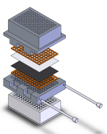  Interlocking Bolt Design  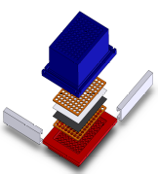  Rail Design  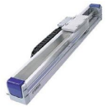  Linear Actuator  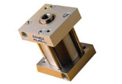  Pneumatic Piston  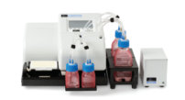  PerkinElmer FlexDrop  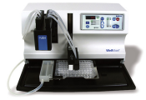  ThermoScientific Wellmate  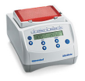  Eppendorf MixMate  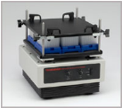  Talboy | Multiple design candidates were developed for the assembly design, the clamping / pressurization station, the liquid dispensing, and the mixing station.  The two predominant designs for the filtration thru-well assembly were the interlocking bolt and rail design, shown left. Each design was required to hold the gaskets in compression and use a minimal amount of parts for assembly. Additionally, they had to minimize weight and footprint. The interlocking bolt assembly uses two bolts to hold the assembly together. The rail design uses 4 c-channels to achieve circumferential clamping.  The clamping and pressurization stations required similar actions, allowing them to be combined into a single station. The two designs considered were a linear actuator and a pneumatic piston. The clamping mechanism needed to provide 800 pounds to construct the assembly. The pressurization mechanism needed to apply 40psi of air to the assembly for filtration and withstand the reactive force. The linear actuator uses an electric motor to generate its power, where the piston uses pressurized air.  The liquid dispensing station required the dispensing of 8 solutions in a limited amount of time. The two systems evaluated were the PerkinElmer FlexDrop and the ThermoScientific Wellmate. The FlexDrop can dispense 4 multiple reagents, while the Wellmate can dispense 1 reagent.  The dry dispensing station must dispense a powder filtration aid. The design selected consists of a mesh screen to dispense the powder. The amount needed to be dispensed was 2 grams ± 25%. The loose tolerances allowed for one simple design to satisfy the requirements.  The mixing station required multiple speeds and a high weight capacity to satisfy the process. Orbital shaker tables, magnetic stirrers, and vortex mixers were investigated. It was quickly determined that only the vortex mixers could fulfill the project requirements. The two vortex mixers considered were the Eppendorf MixMate and the Talboy. The Talboy mixer is a more robust version of the Eppendorf MixMate.

Recommended Design Concept
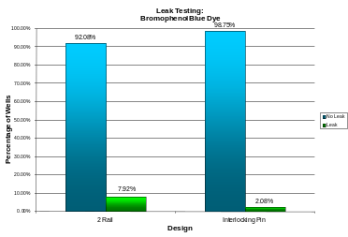  Design Leak Test  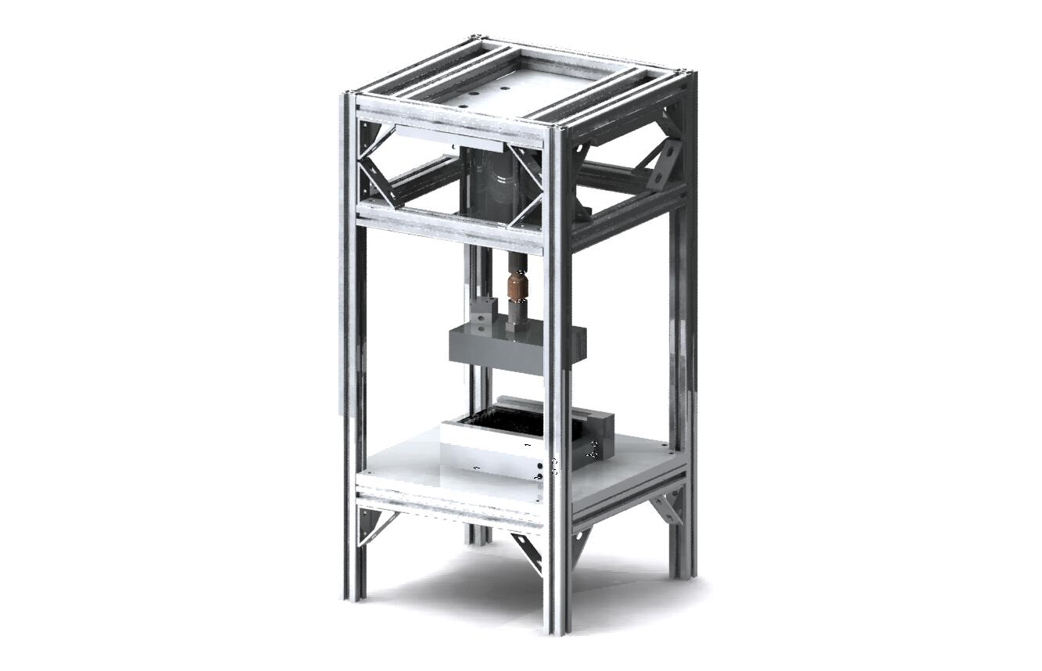  Clamping / Pressurization Station  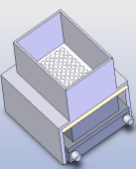  Dry Dispenser  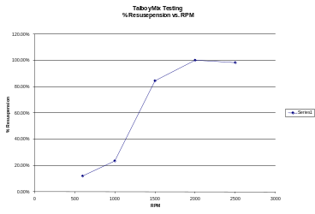  RPM vs % Resuspension  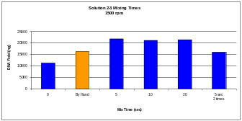  Viscous Solution Mixing Yield | The final designs were chosen from those considered above through analytical investigations, experimentation and key conceptual advantages.  Thru-Well Filtration Assembly  On the basis of theoretical analysis, both assembly designs equally satisfied the requirements. Each assembly weighed 2.3lbs, occupied a footprint of 4.5 x 5.25 inches, and functioned with two clamping components.  Through empirical studies, it was determined that the interlocking bolt design performed favorably. To achieve 25% gasket compression, the maximum stress was 1500 psi, and the greatest displacement was 0.001 inches in the center. Conversely, the rail design had a maximum stress six times greater and twice the displacement.  Experimental leak testing provided conclusive evidence that the interlocking bolt design was superior. A dye was used to quantify the well to well leaking of each assembly. As seen in the graph to the left, the rail design leaked nearly 4 times as much.  Clamping / Pressurization  The pneumatic piston was chosen over the linear actuator based on cost and convenience. Both designs met the requirement of applying a constant force of 800lbs, but the linear actuator was much more expensive.  The availability of pressurized air in the laboratory allowed for simple integration of the pneumatic piston. A frame was designed with a ball joint to allow the pressure head to pivot and equally compress the filtration assembly. A guide rail was included to prevent any rotation of the pressure head and keep alignment with the assembly. This assembly can be seen to the left.  Dry Dispenser  The dry dispenser, pictured left, consists of a 3D printed frame that accepts the filtration assembly. A days worth of filtration aid sits on top of a mesh screen which, when vibrated, allows for the powder to enter in the 96 wells of the assembly.  Liquid Dispenser  The ThermoScientific Wellmate was chosen based on cost, dimensional compatibility, and availability. The PerkinElmer FlexDrop cost $30,000 as opposed to the $9,400 for the Wellmate. To further reduce the cost, a Wellmate was available for use in the Harlow Laboratory. Also, the FlexDrop was not capable of accepting the size of the assembly and would require complete reengineering.  To overcome the fact that the Wellmate only dispenses one solution, a custom design was incorporated to deliver the 8 reagents to the dispensing head. The 8 solutions are dispensed using peristaltic pumps to a common reservoir. The Wellmate is primed then draws the remaining solution from the reservoir and into the dispensing head. Testing proved that passing water through the system adequately flushed the previous solutions out.  Mixing  Testing proved that both the Eppendorf and Talboy mixers were able to mix the solutions in a standard well plate. The added weight of the assembly exceeded the capacity of the Eppendorf. Not only was the Talboy able to handle the load, but it also included a holding platform that allowed for the larger footprint of the filtration assembly.  The chemical process required two distinct mixing steps. The first was to resuspend the E. coli bacteria pellet. The chemistry required a minimum of 5 minutes of interaction time with the bacteria. The Talboy was tested at different rotational velocities for this 5 minute period to determine the optimal speed. A graph on the left depicts this data, showing 2,000rpm in pulse mode achieved the highest level of resuspension. The second requirement of the mixer was to mix the most viscous solutions. A graph on the left shows the DNA yield vs. the mix time. It was determined that mixing for 5 to 20 seconds was sufficient.
Financial Issues
The cost to purchase the filtration assembly and one of each station is approximately $18,100. | The sponsor of this project, Harvard Medical School, imposed the material requirement of Ultem 2300 for the thru-well filtration assembly. Under this constraint, the cost to purchase a manufactured assembly was quoted at $2000. Approximately 60% of the cost incurred is due to machining. This price would expectedly decrease when mass produced.  The clamping and pressurization station has cost $1,400. This includes the piston, the 8020 frame, and the required pneumatic and electronic components. The liquid distribution station has cost $11,200. This includes the Wellmate, 8 peristaltic pumps and the 8020 enclosure that holds the pumps and bottles of reagents. The Talboy mixer costs $3,500. The dry dispenser, adaptor plates, and reservoir for the Wellmate were 3D printed, making cost estimation difficult.
Recommended Improvements
The addition of robotic integration and station control will complete the system. | This project produced the necessary stations to complete the process of extracting Plasmid DNA from E. Coli bacteria. There are two areas of foreseeable improvement. Future integration of a robotic system would allow for a completely automated process. Adding a written control program would tie all stations and robotics together as one system.

