Design of a Liquid Nitrogen Delivery System for Fire Extinguishment

Design Team
Dennis Bernal, Paul Brownsey, John Falkowski
Chris Forrest, Josh Miranda

Design Advisor

Prof. Yannis Levendis

Abstract
This project is the second phase of the design of a liquid nitrogen (LN₂) delivery system for extinguishing small liquid fuel fires. Experiments have shown liquid nitrogen to be a very effective way, and a much safer means than conventional foam methods, of extinguishing liquid fuel fires. Many different possible methods of extinguishing these fires with LN₂ were investigated by the Phase I group. The final solution was to design a system that included a spray nozzle, hose, and a pump truck for applying LN₂. The overall goal of this phase is to continue with the final concept of Phase I and design a manufacturable hose and nozzle that will shoot liquid nitrogen a distance of 10-13 meters. The most challenging factor in this design is minimizing heat transfer in order to keep the nitrogen in its liquid form. Nitrogen changes from its liquid to its gas phase at 77K (-196ºC). In addition to meeting this challenge, the final prototype has been designed with manufacturability and usablity in mind. Two designs are presented in this report. Proof of concept and functionality of desing were demonstrated with the scaled down prototype through sucessful tests. In these tests a distance of about 6 meters was attained with the scaled prototype. The second design is a more ideal solution, and could be developed further to be the production unit.

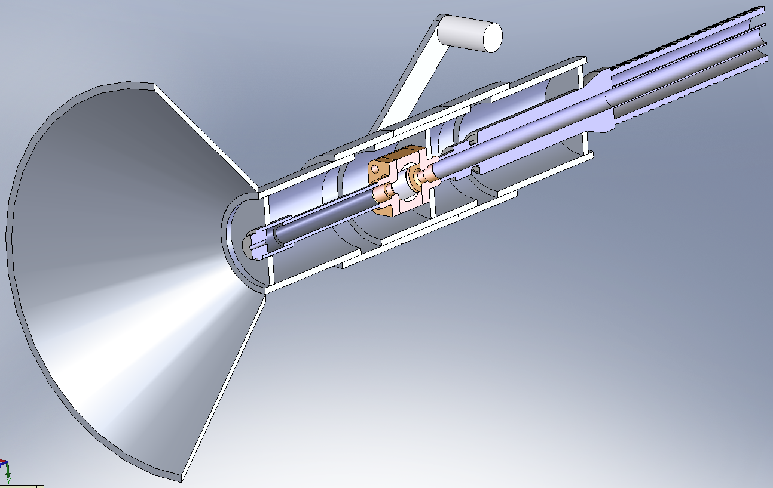
Cryogenic Ball Valve
Vacuum Insulated Hose
Handle
Aluminum Housing
Exit Nozzle
Protective Cone
The Need for Project
The LN₂ application on fires is proven to be a much safer and cheaper method than existing foam extinguishment methods. | For liquid fuel fires, also known as Class B fires, fire fighters currently use perfluorooctane sulphonate (PFOS) foam in order to contain and suffocate Class B fires. There is potential for this foam to easily spill into natural water ways and pollute the environment. PFOS foam has also been found to be hazardous to the environment and humans (Ref. 1).  Experiments have shown liquid nitrogen to be a much safer and very effective means of extinguishing liquid fuel fires (Ref. 5). Benefits to using liquid nitrogen include: low cost, it is an inert gas, and when it vaporizes it leaves no residue to polute the environment.
The Design Project Objectives and Requirements
The proposed design must be able to reach a 10 sq meter fire from 10 meters away, in addition weighing the same or less than current fire fighting water nozzles on the market. | Design Objectives  The main objective of this capstone project is to design a working LN₂ hose and nozzle prototype that could be developed into a production model in the future. It must be designed so that heat transfer is minimized through the hose and nozzle so that liquid is actually delivered to the fire. This prototype must also be able to shoot LN₂ a distance of 10m so that the user may stand a safe distance from the fire.  Design Requirements  The first design requirements for this project were determined from video of previous experiments. In the videos that were examined, a 1 sq m fire was extinguished with the manual application of 0.5 L of LN₂. For fires any larger than 1 sq m, a hose and nozzle would be required. A design goal of extinguishing a 10 sq m fire was set, which would require the application of about 10L of LN₂ at a safe distance of 10m. Due to the extremely low boiling point of nitrogen (77K), an additional design requirement is to minimize the heat transfer through the walls of the nozzle and hose.
Design Concepts considered
The third of three designs was chosen to pursue based on functionality, manufacturability, and cost.  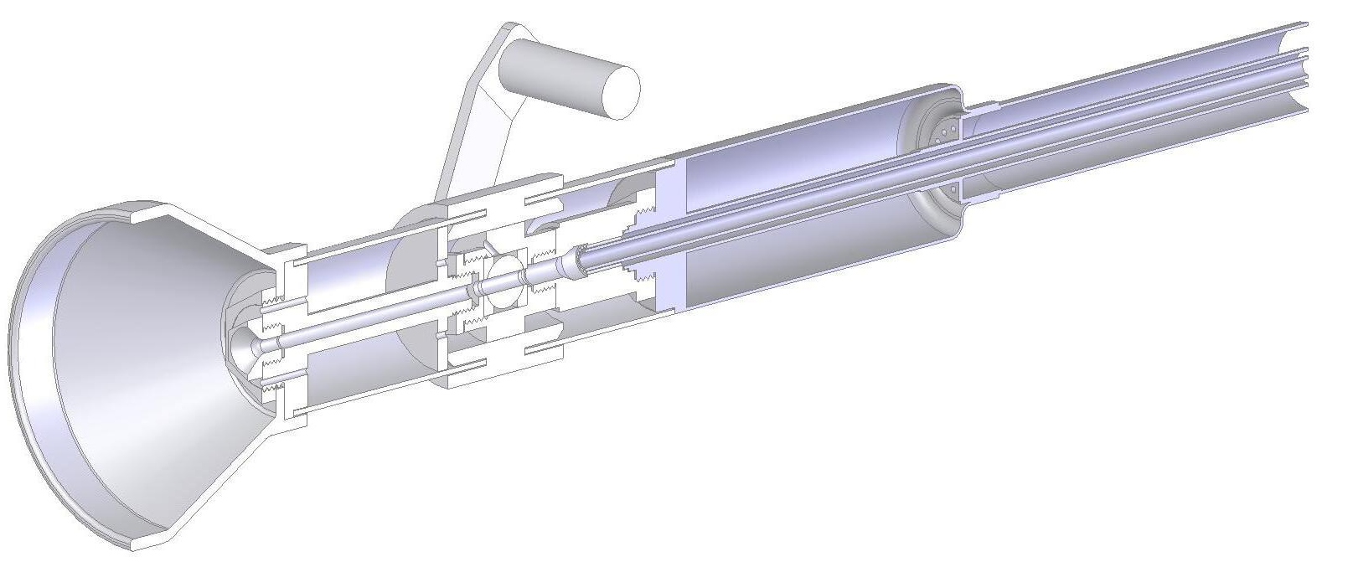  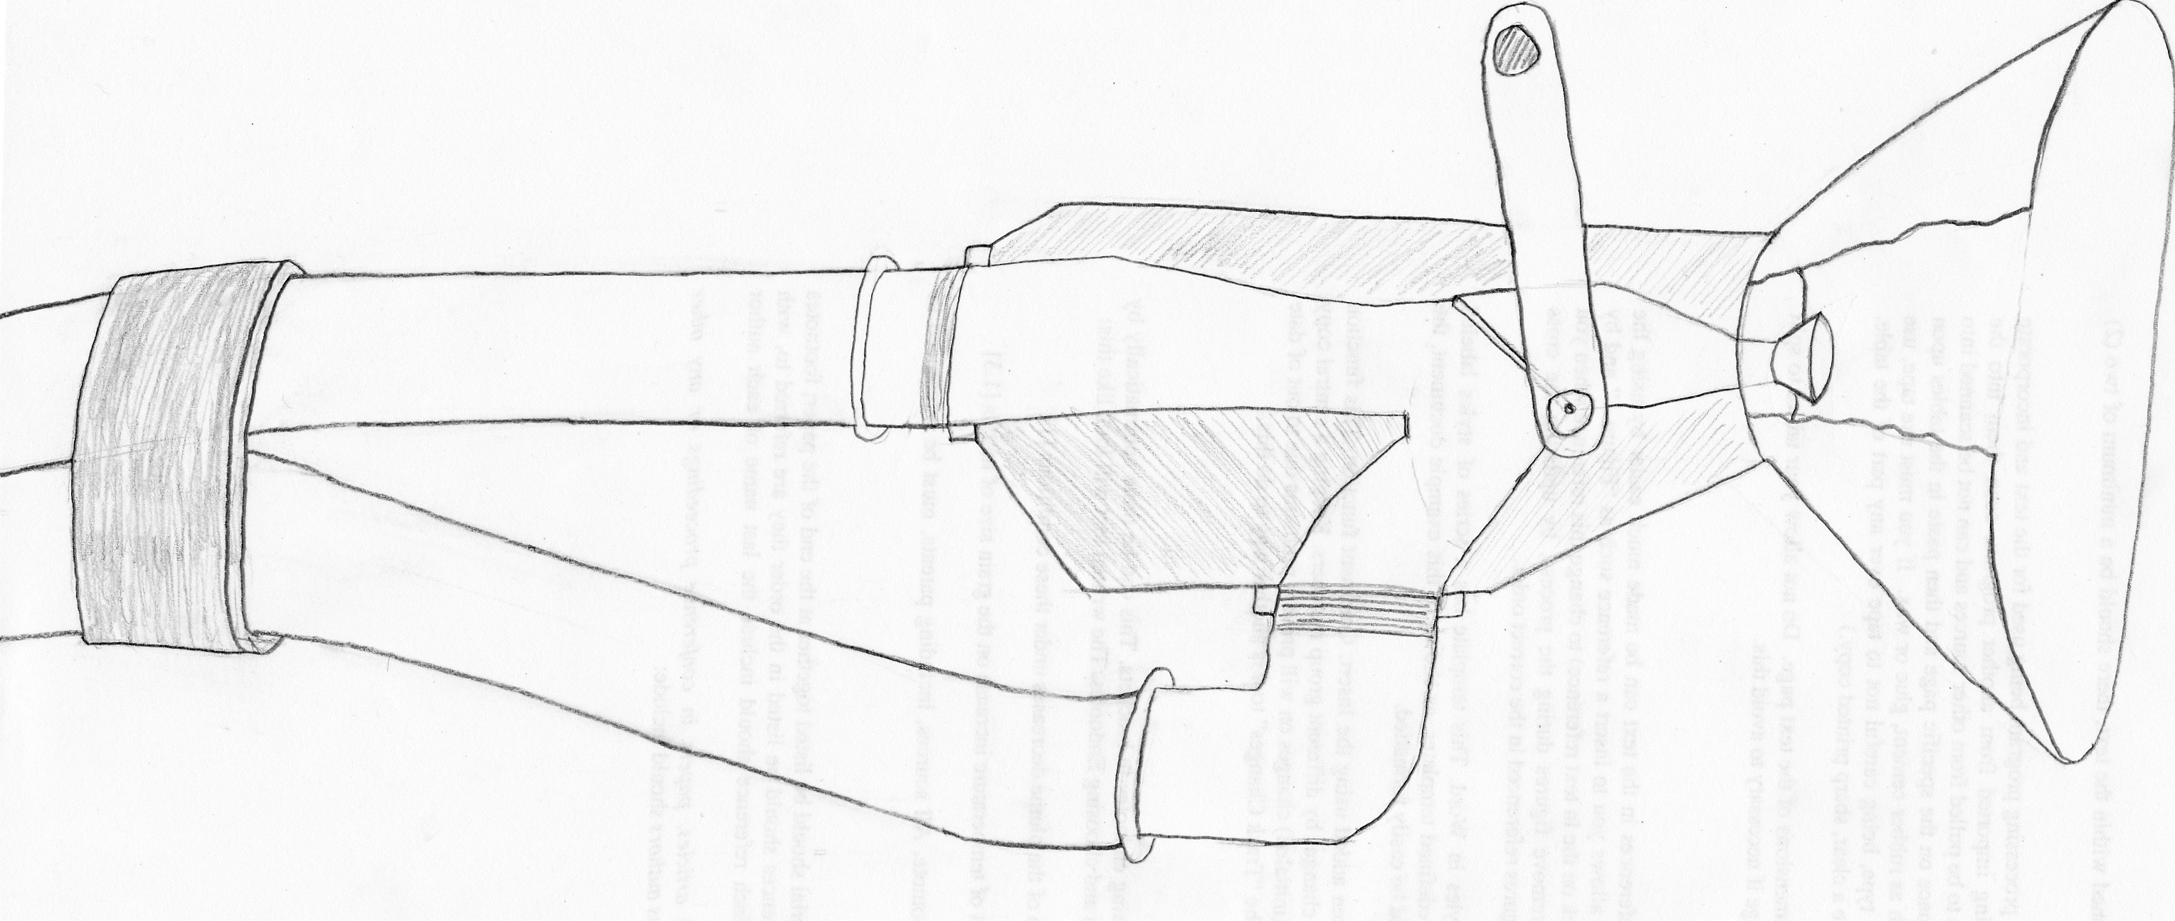 | The following concepts were all considered as candidates for this project phase. They were compared with each other to determine which met the most design requirements, and a concept was identified to pursue.  Concept 1  The first concept considered was the final design of the Phase I Capstone Group. This concept consisted of a phase separator, a tri-axial vacuum insulated hose, a manifold to circulate flow in the hose, and a custom designed valve and nozzle assembly.  Concept 2  This concept consisted of a vacuum insulated bi-axial supply hose connected to a ball valve, and custom nozzle. Attached to the underside of ball valve is an additional bi-axial hose to serve as a return hose. When the valve is closed, the two hoses would provide continuous flow of LN₂ in order to keep the valve and nozzle assembly cold, and eliminate the need for extra cool down time with the valve is opened.  Concept 3  This concept consists of a vacuum insulated supply line, 0.5 in cryogenic ball valve, a 0.5 in stainless steel pipe extension, a 0.5 in to 0.25 in pipe reducer, and a solid stream nozzle tip. These components fit into an aluminum housing similar in size and weight to an existing water nozzle used for fire fighting.  Decision Process  It was discovered that the tri-axial hose, in concept one, is specifically designed to be used vertically in a low flow application, which would not our design specification. This point eliminated concept one. After investigating more characteristics of the vacuum insulated bi-axial hose, it was found that the constant circulation of LN₂ was not needed to pre cool the nozzle. The savings in time would not out weight the cost of an additional hose, eliminating concept two. Concept three was then pursued.
Recommended Design Concept
The design concept consists of a nozzle, housing unit, vacuum sealed hose, and LN₂ tank. It gives a fire fighter a seamless transition of use from a conventional fire hose to the cryogenic hose.  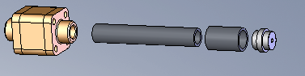  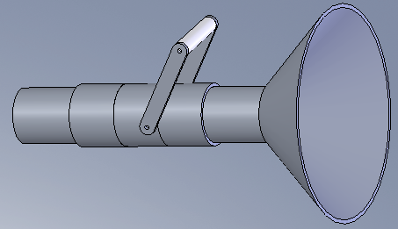 | The recommended design concept was detailed and developed using a combination of design requirements and past work and experiments. Ultimately, the hose and nozzle system was determined to be the most efficient mode of transporting LN₂ to a fire.  Design Description  The ideal model and prototype consist of similar modules; a nozzle, a housing unit, a hose, and a LN₂ tank. Each module was designed with the intent of using mostly off the shelf parts to keep cost low and machining to a minimum. However, materials and pieces were carefully selected to retain the integrity of the system and to keep the vaporization of LN₂ to a minimum. For all intensive purposes, the prototype will be discussed in this section.  The nozzle contains a cryogenically rated brass ball valve, stainless steel extender and reducer, and nozzle tip. A ball valve is ideal for this application in order to keep a low pressure drop over this section and prevent flash vaporization. The extender is required to allow the user to open and close the ball valve completely while using the linkage and handle system located on the exterior of the housing (Rep. 4.3 and Rep. 4.4).  Aluminum is used for the entire housing assembly for two reasons. It is lightweight and able to withstand the hostile environment of a fire. A series of three circular plates are welded into the aluminum tubing to keep the nozzle and hose centered and stable in the housing assembly. A linkage and handle system is installed on the exterior of the housing to give the user the ability to open and close the valve. An insulation, to be determined in the near future, will be used to give the nozzle added protection from radiant heat.  The hose, is provided by Vacuum Barrier Corporation. It has a 15.88mm inner diameter and a vacuum seal. The vacuum seal gives the system an extremely low heat loss rate, which is discussed in Analytical Investigation section low. Threaded connects are used between the hose and the nozzle (Rep. 4.2).  A 3000 gallon transport tank is be used to supply the system. A built-in pump is used to regenerate the pressure in the tank as it is lost as LN₂ is pumped out of it. Cryogenic tanks are advertised with less than one percent per day boil-off rates, this is important to sustain a large amount of LN₂ for long periods of inactivity.  Analytical Investigations  The heat transfer calculations for the hose show that the vacuum seal giving the system the most protection from radiant heat (Rep. Appendix A). The theoretical calculations echo the heat loss claim from Vacuum Barrier of 1 W/m. The extender, on the other hand, will experience the greatest heat loss because of it not having a vacuum barrier. The heat lost over the 17.88 cm extender is about 131 W. This loss can be reduced by shortening the length of the extender and adding a form of insulation to it. Also, as frost and ice builds up on, it will add an extra layer of insulation from atmospheric convection.  Flo-Works and SolidWorks will be used in order to achieve an even more accurate theoretical calculation and determine the areas in the entire system where the greatest heat loss will occur.  Experimental Investigations  Experiments were performed at Vacuum Barrier Corporation to determine the cool-down rate of the entire system and which orifice size will provide LN₂. The nozzle was attached to a 6.1 m hose and then hose was attached to one of two dewers. One dewer was pressurized to 18 psi and the other to 75 psi. It was determined that a set-up consisting of lower pressure, 18 psi, and an orifice size of about 1.27 cm will throw LN₂ approximately 4.88 m at a 45° angle. It took the nozzle 3 minutes to cool from 50°F to -200°F and produce LN₂ at the exit.  Key Advantages of Recommended Concept  The key advantages of this concept are the low heat loss, the accessibility of off the shelf parts, and ease of use. The current design allows for a fire fighter to pick up the unit and use right away. There would be little extra training needed, only to advise the fire fighter of the hazards of using cryogenics.
Financial Issues
The prototype that was built for this project cost on the order of $500. | The prototype nozzle that was built tested for this project cost on the order of $500. The hose used for testing in this project was loaned from Vacuum Barrier Corporation in Woburn, MA. Much of the cost of this design is in the vacuum insulated hose which costs on the order of $85/foot.  An estimated cost of a refined design including ordering a stainless steel ball valve, a vacuum insulated housing, and 30 foot vacuum insulated hose would be on the order of $4000.
Recommended Improvements
A key improvement would be to design a hose that would shoot a horizontal distance of 20 meters or greater to extinguish larger fires. | One key design change would be to insulate the housing. This would include quoting a company that vacuum insulates valves, or designing the housing so that it can be sealed and the air could be evacuated. There also could be further investigation into refining the design for a larger sized fire (i.e. design for a greater shooting distance). This would require a horizontal reach distance of 20 meters or more.

