Rain Gutter Cleaning Device

Design Team
Conor Boyland, Geoff Douglass,
Evan Fink, Amanda Lewis, David Shane

Design Advisor

Prof. Mohammad Taslim

Abstract
The goal of this project was to create a device for cleaning first story home rain gutters. The device was designed for an average home owner and is operated from the ground without the use of a ladder. The team began by testing currently available consumer products for gutter cleaning. After finding out that none of these were particularly effective, the team prototyped and tested several new design concepts. From these tests, it was decided to design a device with a spinning bristle head to sweep debris out of the gutter at the top of a lightweight pole. The final design contains five main components: the pole, bristle head, motor, a gutter engagement system to properly align the device, and a protective shield to control the direction of debris removal. The team has acquired and tested most of the device components, and the rest are on order. The team has undergone a design of experiments to determine the best configuration of bristles in the bristle head. Once the remaining parts are received, the team will assemble the full device and test it against the current market leader, the iRobot Looj. Because this device is intended for use by the average home owner, the team has conducted extensive ergonomic research and has implemented the findings into the design. The team expects the device to be fully functional by the end of the project.
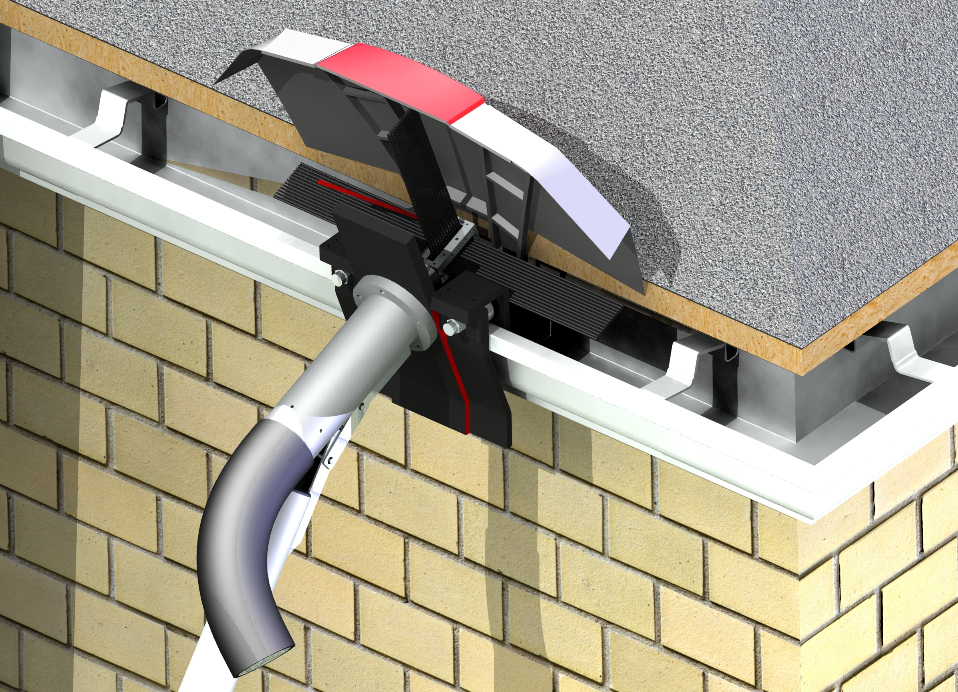
Debris Shield
Bristle Head
Gutter Engagement
Motor and Housing
Pole
The Need for Project

Current gutter cleaning technology is ineffective and usually requires the use of a ladder. | Excessive buildup of debris in a rain gutter can cause roof leakage and property damage. Numerous products on the market claim to easily remove debris from home rain gutter systems. To date, none of these products have proven to be effective or been generally accepted by the consumer market. A product must be created that easily and efficiently removes debris from a rain gutter, allowing for clean flow of water into the downspout.

The Design Project Objectives and Requirements
The project goal was to create a device that cleans rain gutters mounted on first-story homes without the use of a ladder. | Design Objectives  The device must clear debris from first-story rain gutters without the use of a ladder. The gutter system of the home cannot be altered. The device must be operated by one person of average adult strength in a safe and ergonomic manner. The chosen design has moving parts that are located high over the head of the operator, making safety a primary concern. No components of the design should be harmful to the house, rain gutter system, or user during normal operation.  Design Requirements  This device must clean standard K and U-type rain gutters that are mounted a maximum of 12 feet from the ground. To be safely lifted to this height, it must weigh less than 20 pounds. It must also be reasonably priced compared to competing products ($25-$125).

Design Concepts Considered
The group tested prototypes for three different gutter cleaning design concepts: a scoop design, a balloon design and a string trimmer based design.  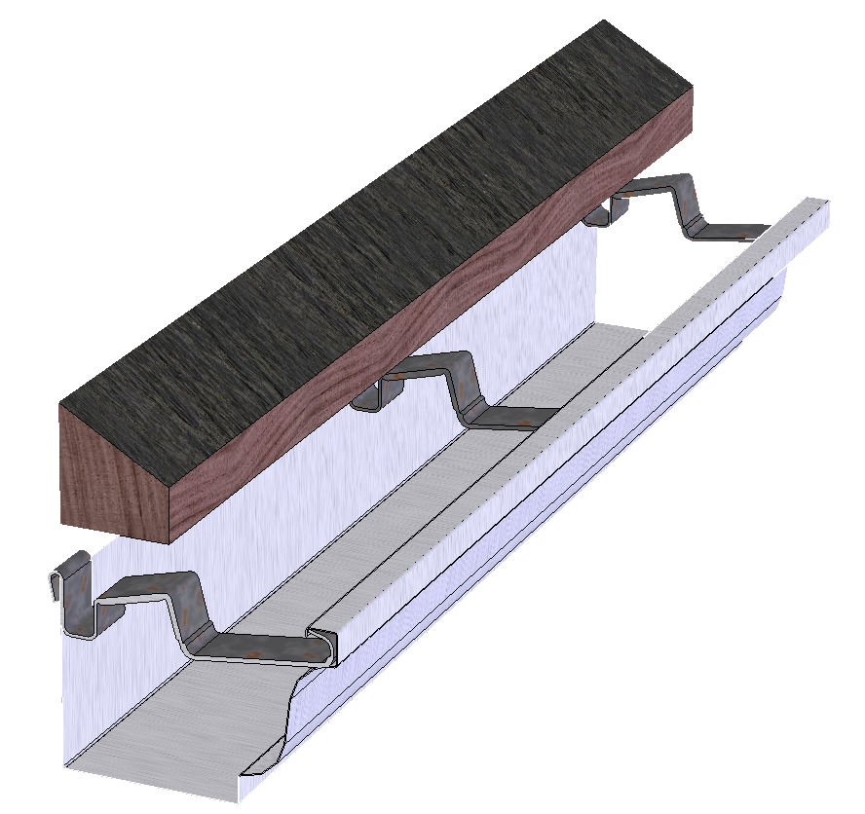  Figure 1: Gutter hangers, the main obstacle of a cleaning device  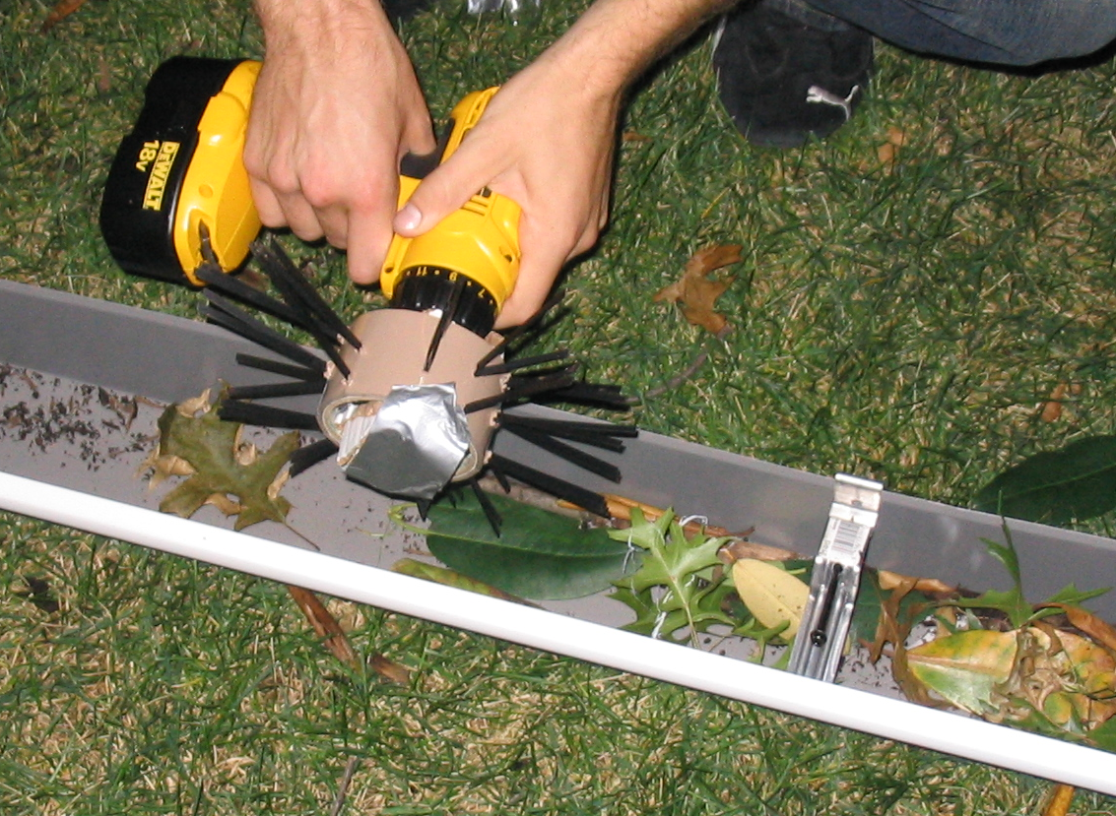  Figure 2: String trimmer prototype being used in gutter with hanger | Existing gutter cleaning methods including tongs and water jets were evaluated through testing of market products. These products did not prove to be effective, so the group focused its efforts on new design concepts. Three major design concepts were developed through a prototype phase to evaluate effectiveness and feasibility: scoop, balloon, and string trimmer designs.  Scoop Concept  Several different styles of scoops were made to evaluate their effectiveness of removing debris from the gutter. The idea of forcing debris up and over the edge of the gutter was also examined, although this was extremely difficult because of the gutter hangers, which mount the gutter to the house and are placed every 12 to 18 inches. The various scoops were effective at collecting almost all of the debris and pushing it down the gutter, but the hangers blocked them from removing the debris completely.  Balloon Concept  The idea of the balloon concept was to slide a flat rigid sheet underneath the debris and expand it to push debris up and out of the gutter. It worked well when used in the right location, but the hangers proved to be a large obstacle for this prototype. If the device expanded underneath a hanger, it would not allow for complete expansion and would not remove much debris. Also, inserting the balloon platform under the debris was too difficult.  String Trimmer Concept  This concept used a rotating head in the gutter with bristles similar to the wire of a string trimmer. As the device spun, debris was tossed from the gutter, leaving a clear path. The string trimmer concept worked very well at clearing debris from the gutter and avoided the hangers by keeping the motor and bristle head above them. The pliability of the bristles allowed them to bend around the hangers, while still effectively moving debris out of the gutter. The success of the string trimmer concept tests inspired the team to create a gutter cleaning device based on this design (Rep. 4.2).

Recommended Design Concept
The chosen design is a rotating brush at the end of an extendable pole. The device is battery powered, engages the gutter, and controls debris flow.  Outer Shell  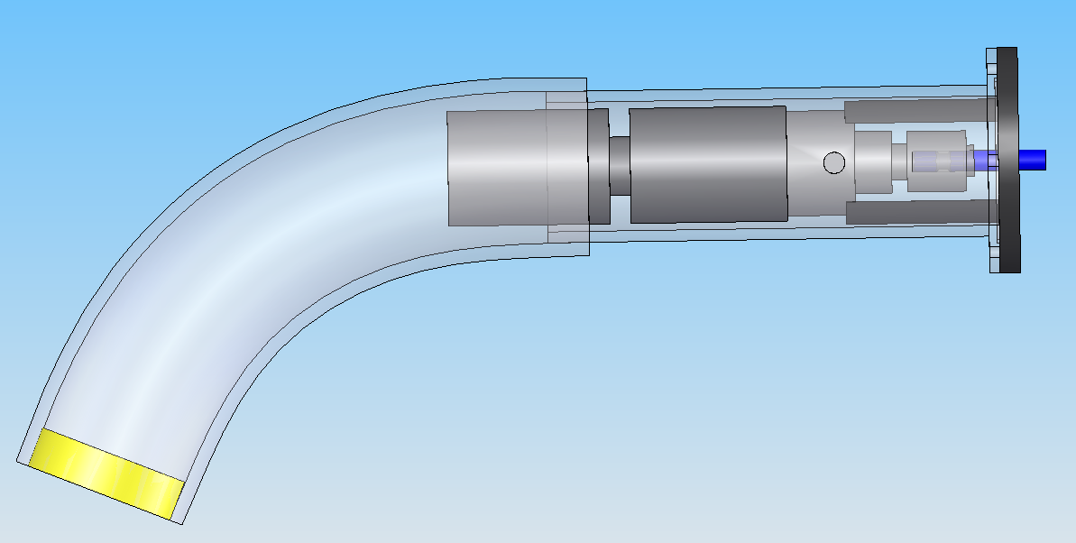  Motor  Alignment Collar  Figure 3: Motor and waterproof housing  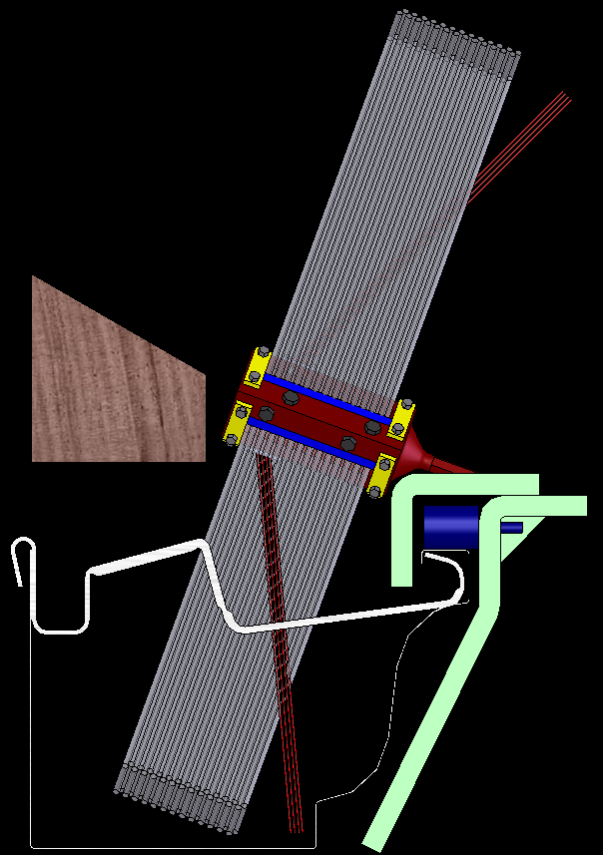  Main Bristles  Angled Bristles  Bristle Head  Gutter Engagement  Rollers  Roof  Figure 4: Bristle head and gutter engagement | Design Description  The gutter cleaning device consists of five major components: motor, bristle head, gutter engagement, debris shield, and pole.  The motor, taken from a Black and Decker VPX wireless drill, spins at 600 RPM and has 50 in-lbs of torque. The team chose a drill based on RPM, low weight and cost. To waterproof the motor, it was encased in a housing consisting of an outer shell, alignment collar and three o-ring seals (Rep. 5.1). The quick-release mechanism that came with the drill was used to connect the motor to the bristle head.  The bristle head is made from machined aluminum. There are two lengths of 14” polypropylene bristles that do the majority of the cleaning and two lengths of 5” angled bristles that reach the more difficult front area of the gutter. The removable bristles slide into the bristle head and are held in place by plates and set screws (Rep. 5.2).  Both the bristle head and motor housing connect to the gutter engagement plate, which is made of ABS plastic. This piece aligns the bristle head parallel to the gutter and supports part of the device’s weight. Its wide angled plate allows the user to easily place the device on the gutter lip. The piece moves along the gutter with a pair of steel rollers and adjusts to fit different gutter lip sizes (Rep. 5.3).  The debris shield also connects to the gutter engagement plate. It surrounds the rotating bristles and deflects flying debris away from the house and user. The prototype is made from a plastic string trimmer shield and thin sheets of galvanized steel (Rep. 5.5).  The entire device is mounted on the end of an aluminum pole that extends from 6 to 12 feet in length. Coiled 14-gauge wire on the inside of the pole connects the motor at the top to the 7 volt Lithium-Ion battery at the bottom. The battery and lower handle, including the trigger mechanism and forward/reverse selector, have all been kept from the original VPX drill. A second handle is mounted further up the pole at an angle and position designed to minimize the moment on the user while handling the device (Rep. 5.4).  Analytical Investigations  Finite element analysis ensured the structural integrity of the gutter system, bristle head, gutter engagement, and pole under normal use. Calculations to minimize voltage drop due to wire resistance led to the selection of 14-gauge wire to connect the battery to the motor. Heat transfer calculations determined the general dissipative heat loss from the motor during use. Measures were taken to maintain this heat transfer when waterproofing the motor.  Experimental Investigations  Motor heat transfer calculations depended on the outlet temperature and air flow rate during use. Temperature was measured by thermocouples, and flow rate by measuring the time taken by the motor fan to fill a 13-gallon bag.  The angle of the pole and device-to-pole connecting bracket was determined by measuring the geometry of the most comfortable holding positions of multiple users.  The placement and stiffness of bristles will be determined through a series of experiments designed to find the optimum bristle configuration. Bristle fatigue properties will be determined by running the device in a gutter system for a fixed amount of time and measuring bristle deflection. Actual battery life will be measured by running the device in a gutter system until the battery dies. The effectiveness of the debris shield will be evaluated during device testing by measuring how far and in which directions debris travels. The overall effectiveness of the device will be evaluated against the iRobot Looj as a measure of mass removed from the gutter vs. time.  Key Advantages of Recommended Concept  The rotating brush design is expected to be more effective at removing debris from rain gutters than the current market leader. The ergonomic handle design and extendable pole make it comfortable and easy to use without a ladder. If manufactured on a large scale, the device would also be significantly cheaper than the market leader.

Financial Issues
The team projects this product to cost $32.17 to manufacture on a large scale, which will translate to a consumer cost of $42.14. | In the creation of the device prototype, the team used an assortment of both readily-available materials and work-intensive machined parts. If manufactured on a large scale, the end unit would be comprised of extruded plastic and easily-made parts. Using some of the group’s resources from previous work experiences, the team determined that this product would cost $32.17 to manufacture on a scale of 10,000 units. The team applied these estimates to a large home improvement store, Home Depot, and used their markup of 31% to project a cost of $42.14 to the end user.

Recommended Improvements
Improvements could include better debris handling, overall weight reduction and added safety mechanisms. | One of the general improvements that can be made is to reduce the overall weight of the entire assembly. This can be done in the pole, the motor, the motor housing and the engagement. The debris shield concept could also be furthered. It is conceptually sound, but further testing would narrow down a more optimal solution. A safety switch is also desired on the engagement piece so that the unit cannot run without physically being in contact with the gutter.

