Development of a Prescription Drug Surveillance System

Design Team
Jenna Eickhoff, Benjamin Harris
Jeffrey Mason, Dan Mitus

Design Advisor

Prof. James C. Benneyan

Abstract
Prescription drugs are the third most abused drugs in the nation. Of the prescription drugs, prescription opioid abuse is a growing problem, especially in the state of Massachusetts. There are currently many different surveillance systems that track the use and abuse of prescription drugs; unfortunately these systems only provide the public with descriptive statistics and overall yearly trends. There is no current system that is able to track prescription opioid data and identify statistically significant changes. The goal of this project is to design and develop a system that will monitor and detect changes in the prescription opioid data in real-time. The system will be designed in Microsoft Access with an intuitive and easy-to-use interface. The database will be based on data collected through the Schedule II Prescription Monitoring Program in Massachusetts. By using multiple Statistical Process Control (SPC) methods and other complex 2-Dimensional (2D) and 3-Dimensional (3D) algorithms, the surveillance system will be able to monitor the prescription data and provide the user with quantitative analysis that will aid in the monitoring and control of prescription drug abuse.
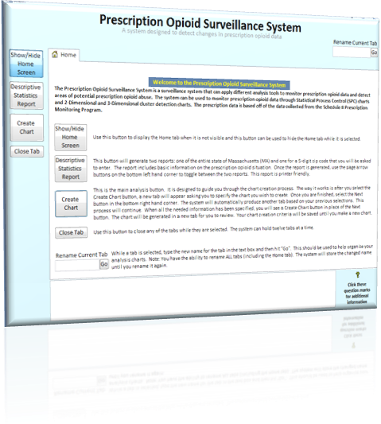
The Need for Project

MA needs a surveillance system that can automatically provide quantitative analysis on prescription opioid data. | Prescription opioid abuse is an ongoing problem in Massachusetts (MA) that they have been unable to control. The Schedule II Prescription Monitoring Program (PMP) has been implemented for over a decade and the prescription opioid analgesics abuse rate continues to grow (Rep. 1.0, 2.0). Although the public health department has used Statistical Process Control (SPC) and spatial methods to study disease outbreaks and infection control, they have not applied this to prescription drug data. MA needs an improved quantitative surveillance system that can effectively monitor and signal when and where the abuse of prescription opioids is occurring, in order to enable the state to take corrective action in a timely manner. The tool needs to be user-friendly and customizable to allow the MA Department of Public Health to respond to areas of need.
The Design Project Objectives and Requirements
The goal is to develop a surveillance system that can accurately detect when and where prescription opioid abuse is occurring in an efficient and reliable manner. | Design Objectives  The goal of this project is to design and develop an application to monitor, detect, and report prescription opioid abuse in the state of MA through multiple Statistical Process Control (SPC) methods and other complex 2-Dimensional (2D) and 3-Dimensional (3D) algorithms. The application must be built in an accessible and commonly used database with a Graphic User Interface (GUI) that is intuitive, easy-to-follow, and aesthetically pleasing. The application must be built for a user that has a working knowledge of basic statistics who will be able to easily view and analyze data of interest.  Design Requirements  In order for this surveillance system to be considered successful, the system must be sensitive, accurate, reliable, intuitive, and able to upload and process large amounts of data. The system needs to be sensitive to allow the user to detect small changes in the drug abuse rate. The user must have confidence that the instance of drug abuse detected is in fact occurring, and that the system is identifying all instances of drug abuse. An intuitive system will allow the user to maximize the potential benefits of the system. Lastly, the system must be compatible with the PMP data and efficiently process the data to create the desired output.
Design Concepts Considered
Applications considered included MySQL, DBASE, and MS Access and were evaluated based on usability for both the design team and the end user. Different methods were discussed to manage ease of customizability and long processing times.  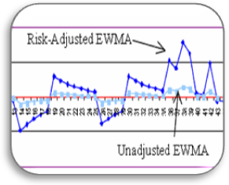  Figure 1 - The J-binomial Risk-Adjusted EWMA increases performance of the binomial Unadjusted EWMA. | The main design elements that were considered fall into three categories: database applications, GUI design, and statistical analysis.  Database Applications Options  Since the development environment needed to be widely distributed and able to handle large volumes of data, the choice of programs was limited. The Microsoft (MS) Office Suite was the most obvious due to the prevalence of Microsoft products in the workplace; however, MySQL and DBASE database applications were also considered. Due to the design group’s experience in the Visual Basic for Applications (VBA) programming language, SQL, and the database’s large data capacity, MS Access was chosen for the algorithm and GUI design.  Graphical User Interface Design Concepts  The design of the graphical user interface went through several iterations over the course of the project. Initially each analysis type would open in a new window, but this led to a large number of windows being opened at one time, making navigation difficult for the user. In considering the need for a smaller number of individual windows, tabbed browsing was considered as an alternative. This concept proved difficult in programming because a dynamic environment was required to accommodate tabs in the GUI. A compromise was found by limiting the number of tabs to twelve which allowed the team to manually code the ability for multiple tabs in the window without the need for dynamic tab creation.  Statistical Analysis Concerns  There were two concerns in the statistical analysis: seasonality and processing time. Prescription opioid data has a proven seasonality by day of week and month. Two methods were considered and implemented to minimize potential error that could occur. The user can opt to have the data deseasonalized which would apply a previously determined seasonality factor to the rate or the user can use the J-binomial control chart (seen to the left) which is able to adjust for this. Design concerns also arose in the programming of the spatial algorithms. To avoid making processing time an issue, some original concepts were introduced in conjunction with Professor James Benneyan in order to reduce the number of computations required in generating the charts for the spatial statistics.
Recommended Design Concept
Through a tabbed browser, users can generate control charts and apply spatial analysis to monitor and detect prescription opioid abuse in datasets of their choice.  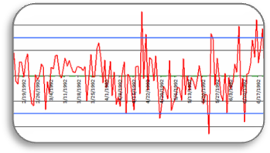  Figure 2 - Standardized p-chart  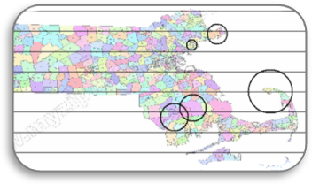  Figure 3 - Sample spatial results | The final prescription drug surveillance system was created and tested in MS Access. Access proved to be a sufficient environment to import and process the data from the PMP. The system is able to monitor the opioid prescription rate, doctor shopping rate, and overprescribing rate through three types of analysis: over time (temporal), over a geographic area (spatial), and over a geographic area over time (spatial-temporal).  Design Description  The temporal analysis utilizes a variety of SPC charts to detect drug abuse such as the standardized p-chart, Exponentially Weighted Moving Average (EWMA) chart, and the J-binomial charts for both the standardized p and EWMA statistics. The use of all the charts created a sensitive and customizable system allowing the user to detect both small and large changes in the prescription opioid data and properly analyze non-homogenous data mitigating the chance for error. To assist the user in detecting pattern changes, a set of commonly accepted detection rules were automatically applied to the results.  The spatial analysis is able to detect areas in MA where prescription drug abuse is occurring. Through the use of the SCAN statistic and Monte Carlo Simulation, the system identifies the zip code center point and the size of the radius of the cluster identifying all the zip codes that are included in the cluster (Rep. 3.2). The spatial analysis allows the user to determine what areas in MA have the largest abuse problems and if there are any recurring spatial patterns.  The spatial-temporal analysis is similar to the spatial analysis except, it provides the user with the ability to analyze the change of the geographic clusters over time. The user can use this analysis to view past trends and then predict where the clusters will continue to move and take corrective action.  The GUI allows the user to easily go through and select the analysis tools of choice, along with the ability to filter out any data that the user is uninterested in analyzing. The chart is produced in its own tab which keeps the users window organized.  Experimental Investigations  The GUI went through a few iterations that were outcomes of user testing by the development team and our target user. The analysis tools went through a validation and verification phase to ensure accuracy of the results. The phase included confirming that generated results followed national and regional trends of drug abuse.  Key Advantages of Recommended Concept  Developing the surveillance system in MS Access with a friendly GUI and an array of customizable analysis tools has provided many advantages for the abuse detection system:  - Monitor prescription drug data over time by SPC methods.  - Monitor prescription drug data over time and space by advanced cluster detection algorithms.  - Automatically signal prescription drug abuse.  - User’s ability to filter out irrelevant data.  - User-friendly interface
Financial Issues
Potential costs will come from software maintenance and the handling and use of confidential data. | The major cost source for the project will be software maintenance which will come from overhead of qualified software developers. Another possible source of costs would be acquiring the data for analysis from a public health department, which could potentially include: licensing fees, background checks for analysts, and other issues related to handling confidential data. Probable costs also exist in the implementation of the system in other geographic areas.
Recommended Improvements
The surveillance system could be improved by increasing the efficiency, user testing, and the addition of more functionality features. | Although the first generation of the surveillance system has been tested and works successfully meeting the design requirements, there are still improvements that could be made that time did not allow for:  - Additional efficiency in the VBA programming.  - Additional GUI testing with persons in MA public health.  - Use of multivariate control charts.  - Result graph for the 3D SCAN.  - Ability to run a complete analysis of the data at once.  - Scheduled automation of importing the PMP data.

