Demonstrating Hydropower

Design Team
Raymond Andrews, Patrick Gray,
Shaun Hamilton, Joseph Jalbert, Peter Privitera

Design Advisor

Prof. Gregory Kowalski

Abstract
The purpose of this design project is to demonstrate the ability to extract usable power from the Stevens River, a shallow, turbulent river in northern Vermont. A small scale cross flow turbine using helically swept blades with airfoil cross sections based on the Gorlov Helical Turbine was designed to extract power from such streams and small rivers. The final product of this design project is a turbine with dimensions of 350mm x 350mm square in cross section, in a supporting frame that allows it to be easily set up in the free flowing Stevens River. The kinetic energy of the water flowing through the Stevens, through an area equivalent to the cross sectional area of our prototype is 62 watts. Through experimental analysis of prototypes early in the design phase, the efficiency expected from the final turbine will be approximately 30%, allowing us to extract 20 watts from the river. The frame supports a generator that provides electrical power which operates a demonstration unit to show the turbine’s power production.

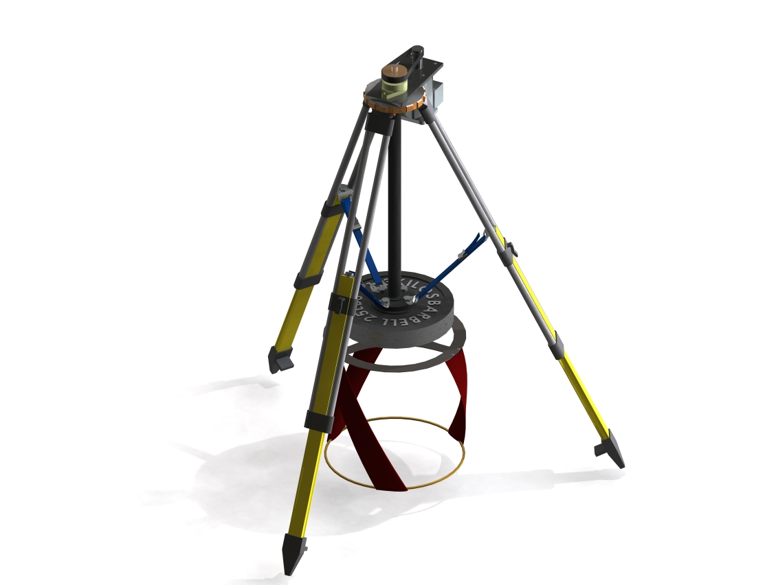
The Need for Project

This project will work to reveal the capability for shallow streams and rivers worldwide to produce usable energy without the use of dams. | Renewable energy resources have the potential to provide vast amounts of energy in today’s society, yet on small scales go largely undeveloped. This project demonstrates the ability to extract usable energy from the Stephens River, to illustrate the capability of all small, shallow, free flowing streams and rivers worldwide to be utilized by nearby homes to supplement their energy requirements. In a society with a growing interest in energy conservation and renewable energies, this project provides a feasible method to produce to sustainable renewable energy for home use worldwide.
The Design Project Objectives and Requirements
Demonstrate the potential for electrical power production from the Stevens River. | Design Objectives  This project must demonstrate electrical power production from the Stevens River, a turbulent stream in West Barnet, Vermont which in the past powered a grist mill using a dam up river from the groups’ installation site. The group’s device should be able to provide a usable amount of power while remaining environmentally friendly and aesthetically pleasing. The final design will be replicable in wider applications, meaning it will perform with similar efficiency in any water source with sufficient flow rate.  Design Requirements  Along with power production, the device should be able to operate year-round, regardless of weather or temperature conditions. The installation will be uncomplicated and the working system will require minimal maintenance. The turbine and its frame system will be able to withstand occasional debris and flooding.
Design Concepts considered
We developed specific candidate design concepts for hydropower turbines, and selected an ideal design based on research and experimentation.  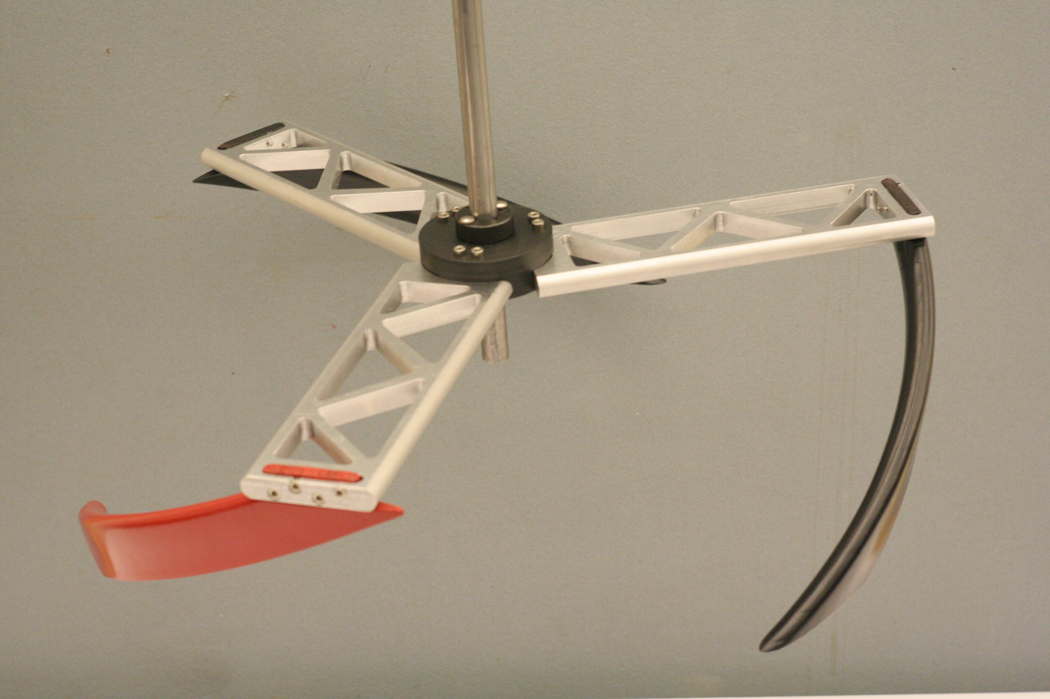  Cantilevered 500mmx125mm Turbine  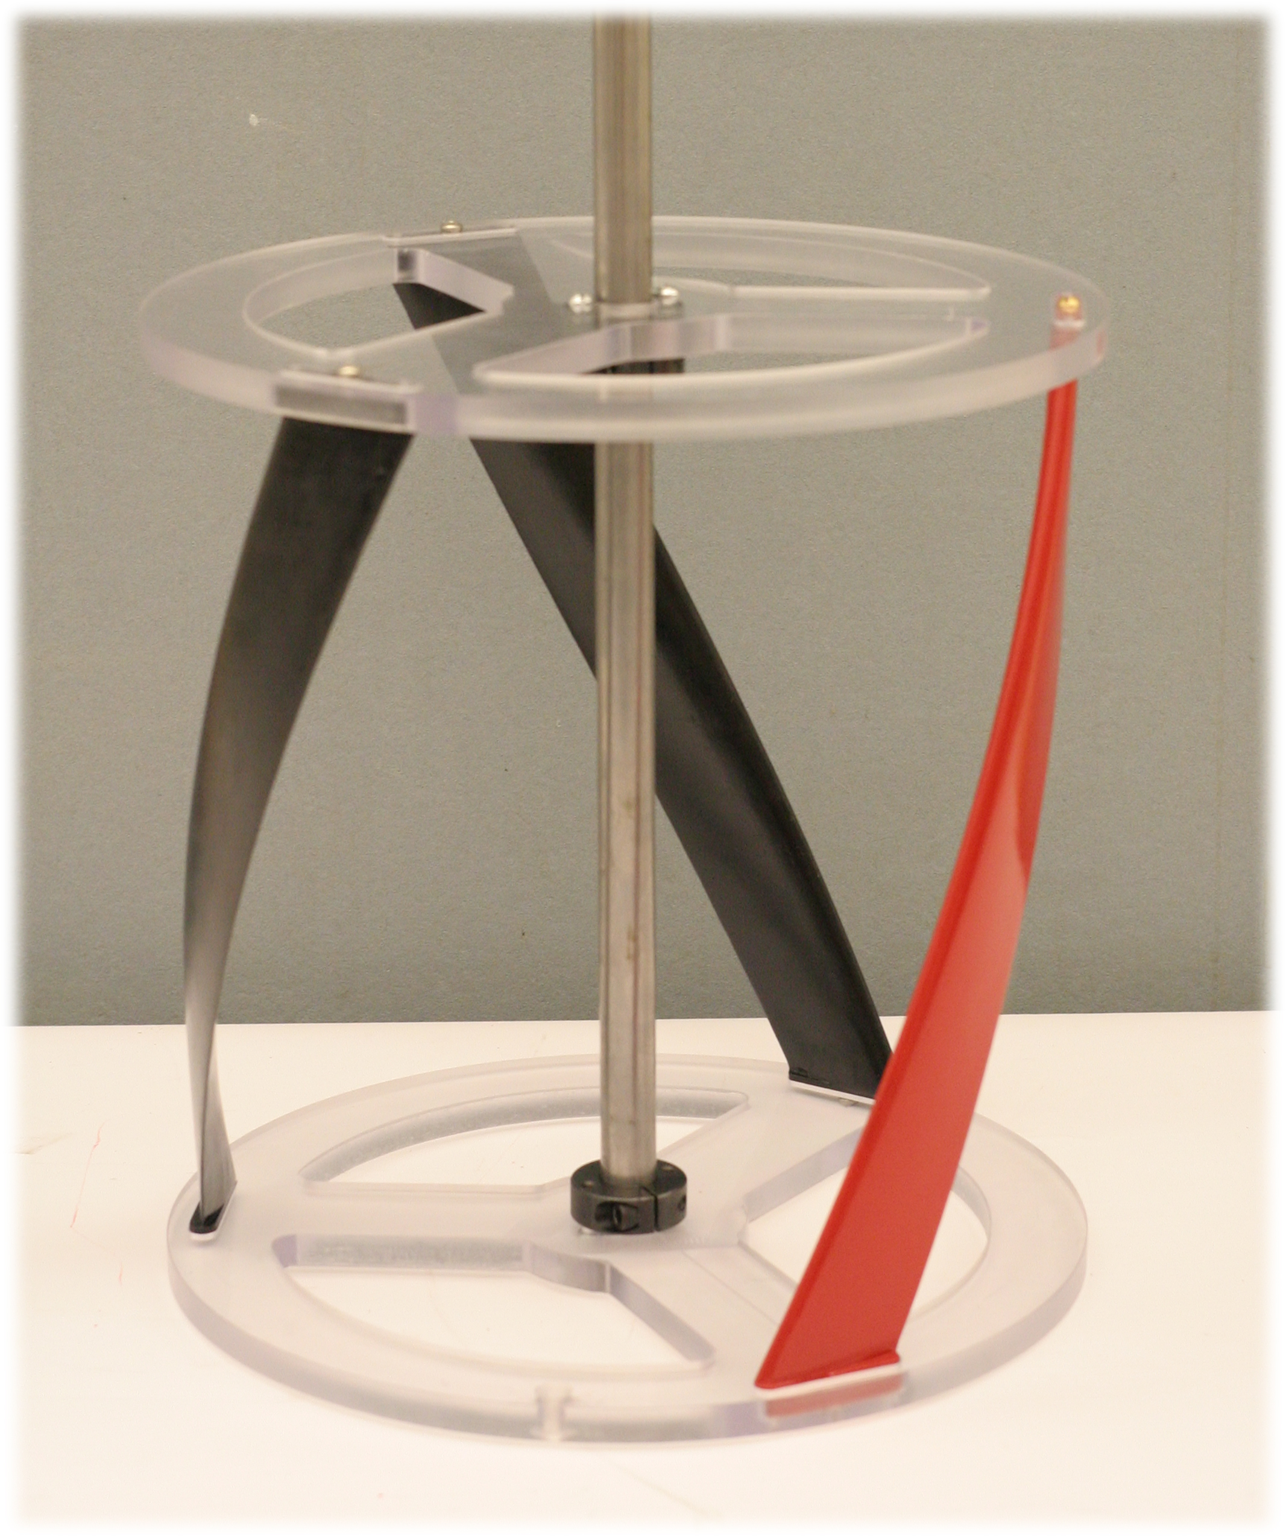  250x250mm 30% Solidity Turbine | The group considered many design concepts to demonstrate the hydropower potential of the Stevens River test site. Decisions were made relating to the method in which the energy is harnessed, the type of turbine used, and the method for using the power produced at the turbine shaft. Factors that contributed to these decisions included environmental impacts, cost of implementation, efficiency, novelty, feasibility, ease of installation, and ability to be replicated in wider applications. The consideration of these criteria resulted in an elegant and robust design that not only satisfies the needs of the site on the Stevens River but also those seen in similar streams throughout New England and world wide.  Conventional hydropower systems generally require water to pass through a turbine at high pressure. To implement one of these systems, a method for generating a static pressure head is required, usually by the use of a dam or length of pipe to deliver water to the turbine from a higher elevation. After conducting a site survey it was determined that it was not feasible to use this type of system at the Stevens River site, because of such factors as cost, ease of installation, novelty, and environmental impact. For these reasons the design team decided to pursue an in-stream turbine system using a variation of the Gorlov Helical Turbine (GHT), a turbine design that has been shown to perform efficiently in the type of current found at the test site.  The group conceived of many different configurations that would permit a turbine to occupy the maximum usable space in the stream. Parameters such as turbine orientation (horizontal or vertical) and the height to diameter ratio were researched and tested to determine the proper dimensions and orientation. Solidity is another important parameter that influences the performance of an in-stream turbine. Solidity is a measurement of the turbines’ blade area compared to the total turbine area. Five different blade configurations and two different turbine geometries (square and cantilevered) were built and tested at MIT’s towing tank facility to determine which solidity and mounting configuration would perform the best in an environment like the Stevens.  Many supporting structures for the turbine were considered such as floating platforms, concrete pylons, and guy wires to securely hold the turbine in the river. Consideration also went into drive-train selection, including gearing, belting, and direct drive connection to the generator. Generator selection has been ongoing, and has the unique challenge of finding a generator that is maximally efficient in the speed and torque ranges that the turbine operates within.
Recommended Design Concept
The design incorporates a three bladed, 40% solidity helical turbine with a 350mm diameter and a square height to diameter ratio. The turbine is mounted on a tripod stand for simple installation and stability.  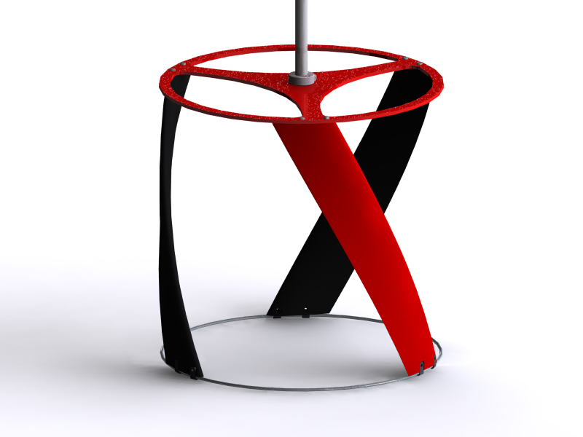  Final Turbine Design, 350x350 square  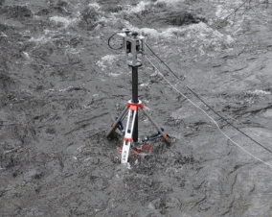  System Set up in Steven’s River | The main component of the group’s design is a Gorlov helical turbine, which is a cross flow turbine whose blades follow a helical sweep about its axis of rotation. The group’s turbine is cylindrical in shape, with a 350mm diameter and height. The cross section of each blade is an airfoil shape, and each blade is swept over 60 degrees. The turbine has three blades, which is the optimal number required to reduce torque pulsations throughout the turbine’s rotation. The blades are made from printed ABS plastic, and are mounted to a steel endplate on the top end which is coupled to the turbines shaft. The bottom of the blades are attached to a thin steel hoop, to provide stiffness in the direction normal to the turbines shaft, reducing the effect of centripetal force bending the blades outward as it rotates.  The size and shape of the airfoil cross section in relationship to the turbines overall dimensions is a critical factor in the turbine’s overall performance. This relationship between the airfoil dimensions and turbine diameter correlates to the turbine’s solidity. Through research and experimentation the group determined that a turbine with 40% solidity is close to ideal for the stream in which the turbine will operate. The turbine can generate power in any free flowing water source with sufficient velocity, without the use of a dam or any other pressurized water delivery system. This is because the turbine generates power through the interaction between the flowing water and the turbines blades. The airfoil cross sections generate lift and drag forces as the water passes over their surface. Because the turbine rotates in the water, the relative velocity going across each blade is constantly changing in both magnitude and direction throughout the turbines rotation. More in depth analysis regarding how the turbine generates power can be read in the groups report in the “Lift Drag and Torque” section.  To support the turbine, a structure was designed to support it and all the equipment needed to turn hydro-dynamic energy into electricity. The design criteria for this structure were stability, ease of installation, environmental and aesthetic impact, application flexibility, and cost. A surveying tripod was selected as the main component of the frame. Concerns of the structure’s stability were satisfied through static tipping and bending stress calculations.  The turbine is suspended from the center of this tripod on a shaft that runs axially through a section of pipe. The turbine and shaft are supported in the vertical direction by a conical thrust bearing at the upper end of the shaft. This bearing is a critical component in the over all design, as preliminary testing before the implementation of the thrust bearing showed significant friction losses in the shaft. The bearing greatly limited the losses experienced due to friction. At the lower end of the pipe the shaft is constrained by a lubrication free delrin and stainless steel ball bearing. The pipe is attached to the tripod structure using a shaft collar, which allows for the vertical adjustment of the turbine allowing the turbine to be placed at an optimal height.  The free hanging end of the pipe is attached to the legs of the tripod with adjustable nylon straps. These straps have the dual function of preventing the turbine from swinging as a pendulum in the water, and also of keeping the tripod’s legs from moving outward from their intended positions.  The power from the turbine’s shaft is transmitted to a generator mounted on top of the tripod using a chain drive system with multiple possible gearing combinations. The generator requires an optimal angular velocity in order to perform in an efficient range.
Financial Issues
Prototype costs are in the $650 range, which is low compared to similar manufactured products. | The cost of the prototype produced at the end this project is roughly $650. For a production model using injection molded parts in a high volume, this price could be easily reduced to roughly $400 per unit. At a cost of $0.09 per kWH, the simple payback of the device can be determined. Assuming a 20W (.02kW) output from the turbine, the cost savings on the owner’s energy bill would amount to $15.76 per year and the device would pay for itself in 25 years. This figure may not seem impressive, but when one considers that the device is scalable and also able to operate with similar efficiency in faster moving currents, these savings could be much higher depending on the installation site since the power output is proportional to the turbines area and also to the water velocity cubed. Also, this energy is completely green and environmentally friendly compared to commercial energy purchased from power plants.
Recommended Improvements
Optimization of the generator and electrical system will boost performance. | A thorough investigation into the electronics at the turbines shaft output could improve the design immensely. This would include a more in depth look at the type of generator that would optimize electrical power produced. Experimental testing has shown that over 55% of the losses in the over-all system are experienced in the generator.

