Thermal Loop Flow Sensor
Design Team
Andrew Boyajian, Derek Engel
Erin Harrison, Sara Underwood

Design Advisor

Professor Mohammed Taslim

Design Sponsor
Waters Corporation

Abstract
Waters Corporation currently uses a nanoflow meter developed by Bronkhorst. The concept of this flow meter is based on thermal anemometry, which is very susceptible to ambient temperature effects. The goal of this project is to improve the existing thermal flow measurement method. Several design concepts were developed and from these a recommended design concept was chosen. A base block acts as a thermal mass, and loop geometry is used for the measurement portion of the flow path. Analytical investigations show that this design is valid and improves thermal sensitivity by greatly reducing the effects of fluctuations in ambient temperature. Experimental investigations tested the thermal loop configuration. Results showed that there is a measurable temperature difference between the inlet and outlet side of the loop which comes from the heat added to the flow by a heating element. This temperature difference gives the ability to measure flow, proving that the design is valid.

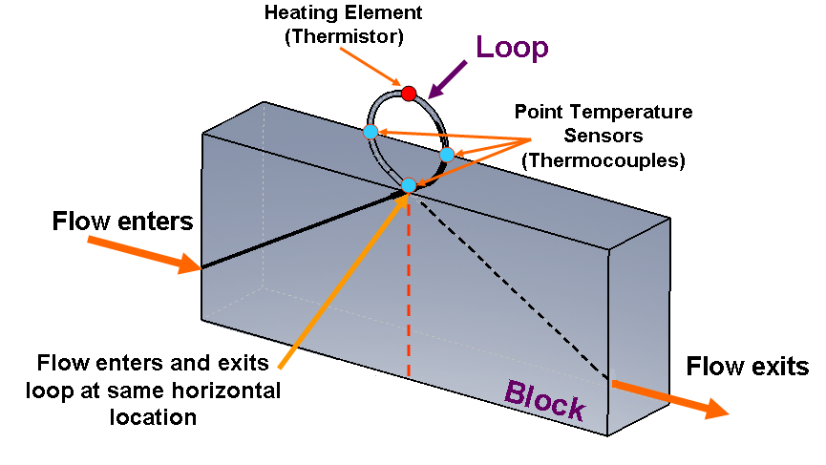

The Need for Project

Current nanoflow meters do not meet the requirements the sponsor, Waters Corporation, desires. | There is currently a fully functional nanoflow meter in use at Waters Corporation, the sponsor for this project. The nanoflow meter is based upon the concept of thermal anemometry (Rep 2.2.1). Current products on the market that use this method of measurement are very susceptible to changes in ambient temperature, which leads to inaccurate flow rate measurements. Waters Corporation desires a nanoflow meter that reduces the effects caused by ambient temperature fluctuations.
The Design Project Objectives and Requirements
Minimizing the effects of fluctuations in ambient temperature is the main objective of this project. | Design Objectives  The main objective of this project is to minimize the effects of ambient temperature. In addition, developing a nanoflow meter that is manufacturable for a lower cost than current nanoflow meters is desirable. These are the most important areas of improvement to Waters Corporation.  Design Requirements  The current nanoflow meter in use at Waters Corporation has a thermal sensitivity of ± 0.2% FS/°C (Ref 1). The ideal nanoflow meter will have negligible thermal sensitivity. For this project, developing a design that has the capability of approximating a negligible value is desired. The nanoflow meter Waters Corporation currently uses costs around $1000. They want a device that will be competitive in the market with existing nanoflow meters. Designing a device that is manufacturable for under $400 will accomplish this goal. (Rep 1.2).
Design Concepts Considered
Three design concepts were developed. Two of these concepts have the capability of meeting the requirements of Waters Corporation.  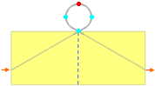  Front View Showing Flow Path | Three design concepts were developed using thermal measurement principles, which is the desired measurement method specified by Waters Corporation.  Expanded Heating Elements  A concept was developed that expands upon the configuration of existing nanoflow meters. This configuration involves the use of two heating and sensing elements wrapped around the flow tube to measure the flow (Rep 2.2.2). The proposed concept adds additional heating elements along the flow path. One of the elements is placed before the flow enters the measurement region and the other is placed after the flow exits the measurement region. By controlling the temperature at these two locations, the effects of fluctuations in ambient temperature will be reduced (Rep 5.1.1).  Thermal Loop  Creating a loop in the flow tube allows the flow to enter and exit the measurement region of the tube at the same physical location horizontally (Rep 4.1.1). The loop also allows the flow to travel through a base block, which acts as a thermal mass, for an extended period of time. This helps equalize temperature at the entry and exit points of the measurement region (Rep 4.1.2). Thermocouples are placed about the loop to measure the temperature profile when heat is applied at the top through the use of a thermistor (Rep 5.2).  Two concepts were developed using loop geometry. One concept was developed where the tubing entered and exited the loop at a horizontal distance of 0.1” apart (Rep 5.1.2). This geometry proved useful in preliminary analysis models. A refined concept was developed to resemble the desired geometry and improve the machinability of the design (Rep 5.2). From this concept, two prototype designs were developed. One for development at an outside vendor and one for development at the Northeastern University machine shop. Both of the thermal loop concepts developed have the capability of meeting the requirements specified by Waters Corporation.
Recommended Design Concept
The recommended design involves a base block acting as a thermal mass and loop geometry for the measurement portion of the flow path. Analytical and experimental investigations show that this design concept is valid.  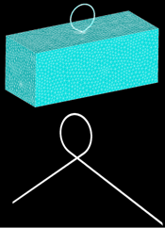  Finite Element Models for Analysis in ANSYS and Fluent  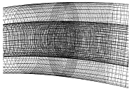  View of Fluent Model Showing Mesh Detail  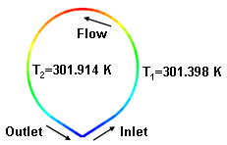  Result for Moving Fluid with Heat Flux Input at Loop Apex  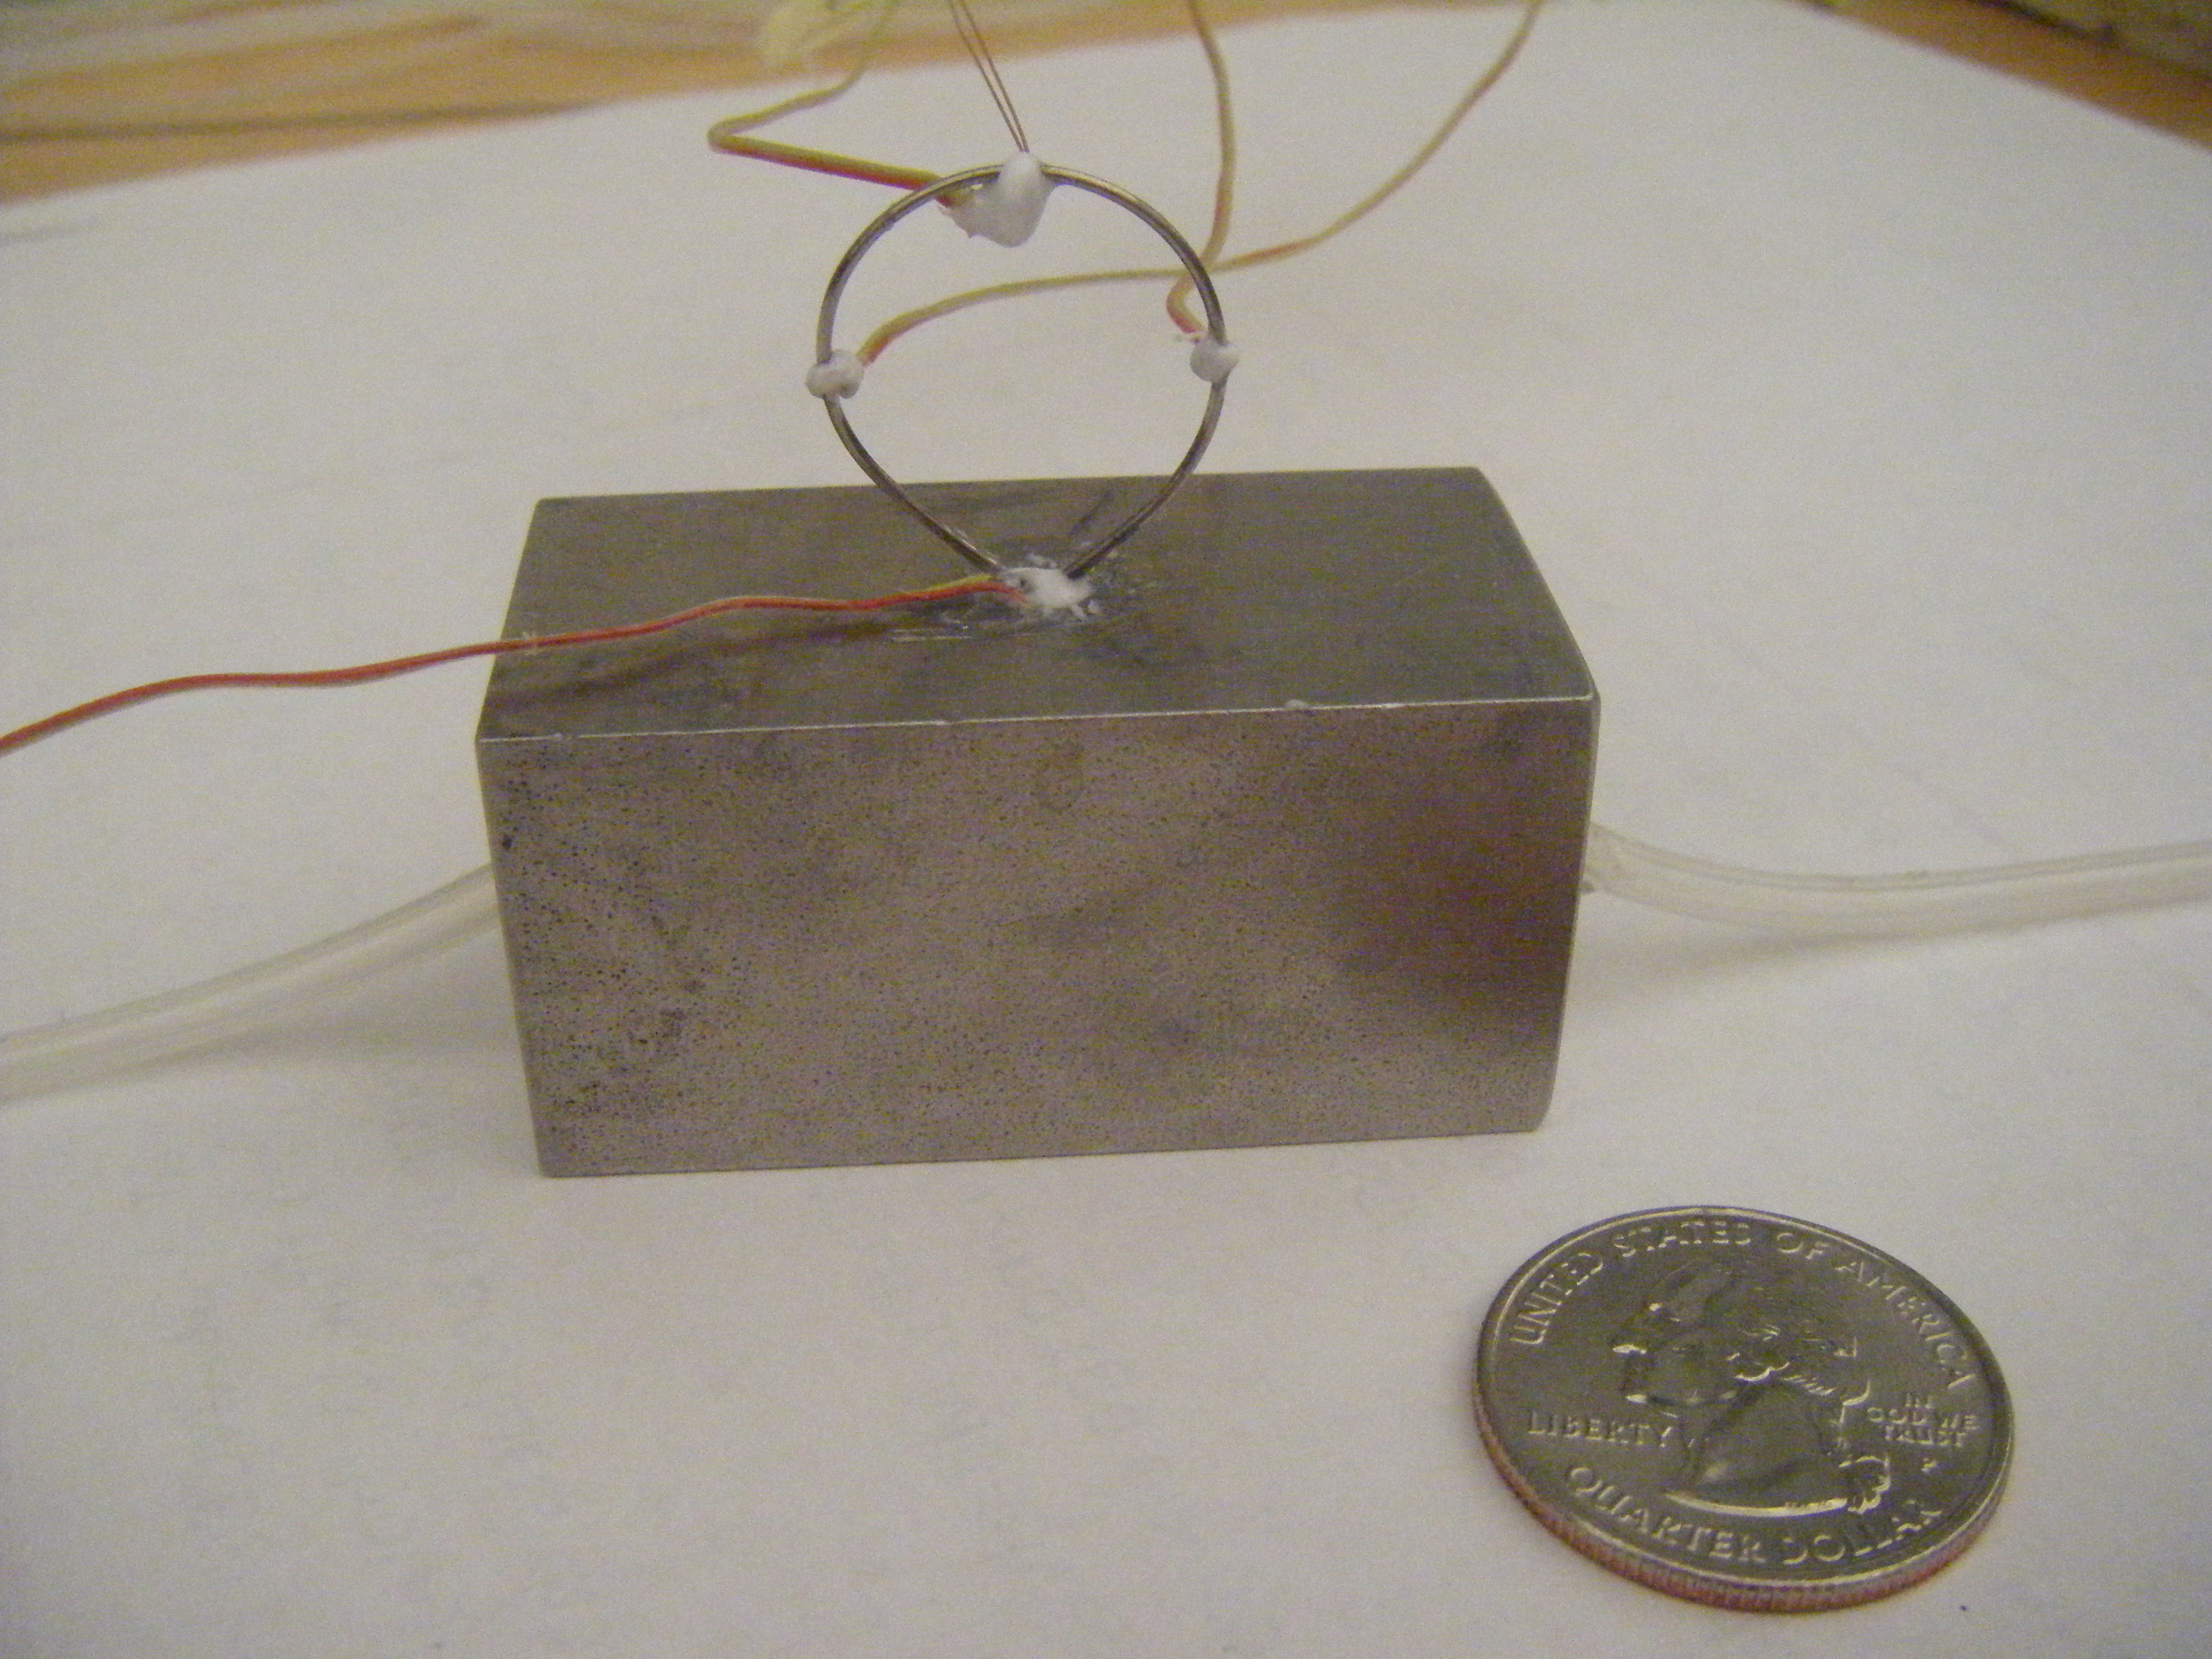  Prototype Model with Thermocouples and Thermistor for Experimental Testing | Design Description  To meet the requirements of Waters Corporation, the recommended design uses loop geometry for the measurement portion of the flow meter. Three thermocouples are placed around the loop. One is located at the base and the other two are located at 90° and 270° around the loop. A thermistor is placed at the apex of the loop and is used as a heating element (Rep 5.2). From this design, two prototypes were developed based on machinability. The first was manufactured by an outside vendor. In this design, holes were drilled into a stainless steel block. One end of a piece of stainless steel tubing was inserted 0.1” into the top of the block, wrapping around to form a loop with the other end also inserted 0.1” into the block (Rep 5.3.2). The second design was built at the Northeastern University machine shop. The base block uses the same design as the first prototype, but was cut in half and made from aluminum. Each half of the block had a 0.031” slot cut to a depth of 0.031”. This size slot was used to accommodate the stainless steel tubing (outer diameter 0.028”), which runs along the entire length of the slots. The tubing was placed in the slot on one of the halves, bent into a loop, and placed in the slot on the other half of the block. The two block halves were held together with four 4-40 screws. Thermal grease was used to fill the gap between the tubing and the edges of the slot (Rep 5.3.1).  Analytical Investigations  In order to validate the recommended design, a thermal analysis was performed. Finite element models were created for use in both ANSYS and Fluent. The initial loop design with a 0.1” gap was used to develop the ANSYS finite element model. Analysis of this model showed that the block acts as a thermal mass. It also gave preliminary results for the temperature distribution about the loop when the flow is stationary (Rep 6.2.). A second finite element model was developed for analysis in Fluent. The flow path of the recommended design was modeled and analyzed. For the analysis, water was used as the solvent. A heat flux of 19300 W/m² was applied at the top of the loop while a flow rate of 0.00164 m/s was flowing through it. This flow rate corresponds to a volumetric flow rate of 2 μl/min, which is the target flow rate specified by Waters Corporation. Results of the analysis showed the temperature distribution about the loop for a moving fluid. A change in temperature from the inlet side of the loop to the outlet side of the loop was found to be 0.516 °C. The model was sufficient for determining the effects of varying tubing material, fluid properties, and flow rate. Overall, the results of the analytical investigations show that the recommended design is valid (Rep 6.3).  Experimental Investigations  In addition to the analytical investigations, prototype testing was performed to further validate the design. A nanoflow syringe pump was used to control the flow rates. A thermistor and thermocouples were attached to the loop with conductive epoxy. In addition, thermocouple was epoxied to the thermistor so that its temperature could be monitored. A power supply was used to control the power to the thermistor. The thermocouples were measured through a date acquisition system, DAQView (Rep 7.2). Test sets for each prototype were run at voltages of 8.49 V, 10 V, and 12 V. The flow rates tested ranged from 10 nL/min to 5 μL/min. The results showed a temperature difference between the thermocouple measuring the inlet side of the loop and the thermocouple measuring the outlet side of the loop. Lower flow rates gave a temperature difference of around 0.2˚C while higher flow rates gave a temperature difference of around 0.6˚C. Flow rate can be measured from the temperature difference. By measuring a temperature difference through prototype testing, it is shown that the recommended design will have the ability to measure flow rates with reduced sensitivity to ambient temperature fluctuations (Rep 7.4).  Key Advantages of Recommended Concept  The recommended loop design allows the fluid to be in direct contact with the base block. With the block acting as a thermal mass, the effects of ambient temperature are greatly reduced. The temperature of the fluid equalizes by the time it reaches the measurement portion of the flow path (the loop). The thermocouples act as small size temperature sensors which give a more accurate output then the coil configuration used in current nanoflow meters (Rep 3.3).
Financial Issues
Waters Corporation desires a flowmeter that can be manufactured for under $400. The cost of a prototype was $200. | The nanoflow meter currently used by Waters Corporation costs around $1000. In order to compete in the market with existing nanoflow meters, a new flow meter needs to be developed that is manufacturable for under $400. The prototype developed for proof of concept cost the group $200 per unit.
Recommended Improvements
The design can be improved by using smaller thermistors and by reducing the tubing size. | To further improve the recommended design, thermistors that are smaller than the outside diameter of the tubing (0.028”) should be used. Additional enhancements could be made by decreasing the response time and increasing the flow rate range. This may be done by reducing the tubing size, allowing for the measurement of lower flow rates.

